**Assignment 1**

Aim: Implementation of Android Activity Lifecycle CODE:

*MainActivity.java* package com.example.practice;

import androidx.appcompat.app.AppCompatActivity; import android.os.Bundle; import android.widget.Toast;

public class MainActivity extends AppCompatActivity

{

@Override protected void onCreate(Bundle savedInstanceState)

{

super.onCreate(savedInstanceState); setContentView(R.layout.activity_main);

Toast.makeText(getApplicationContext(), &quot;Inside OnCreate&quot;,

Toast.LENGTH_SHORT).show();

}

@Override

protected void onStart()

{

super.onStart();

Toast.makeText(getApplicationContext(), &quot;Inside OnStart&quot;, Toast.LENGTH_SHORT).show();

}

@Override protected void onResume()

{

super.onResume();

Toast.makeText(getApplicationContext(), &quot;Inside OnResume&quot;, Toast.LENGTH_SHORT).show();

}

@Override protected void onPause()

{

super.onPause();

Toast.makeText(getApplicationContext(), &quot;Inside OnPause&quot;, Toast.LENGTH_SHORT).show();

}

@Override

protected void onStop()

{

super.onStop();

Toast.makeText(getApplicationContext(), &quot;Inside OnStop&quot;, Toast.LENGTH_SHORT).show();

}

@Override

protected void onDestroy()

{

super.onDestroy();

Toast.makeText(getApplicationContext(), &quot;Inside OnDestroy&quot;, Toast.LENGTH_SHORT).show();

}

}

# activity_main.xml

<?xml version="1.0" encoding="utf-8"?>

<androidx.constraintlayout.widget.ConstraintLayout xmlns:android="http://schemas.android.com/apk/res/android" xmlns:app="http://schemas.android.com/apk/res-auto" xmlns:tools="http://schemas.android.com/tools" android:layout_width="match_parent" android:layout_height="match_parent" tools:context=".MainActivity">

<TextView android:layout_width="wrap_content" android:layout_height="wrap_content" android:text="@string/string"

android:textAppearance=”@style/TextAppearance.AppCompat.Large”; app:layout_constraintBottom_toBottomOf="parent" app:layout_constraintEnd_toEndOf="parent" app:layout_constraintStart_toStartOf="parent" app:layout_constraintTop_toTopOf="parent" />

</androidx.constraintlayout.widget.ConstraintLayout>

OUTPUT:

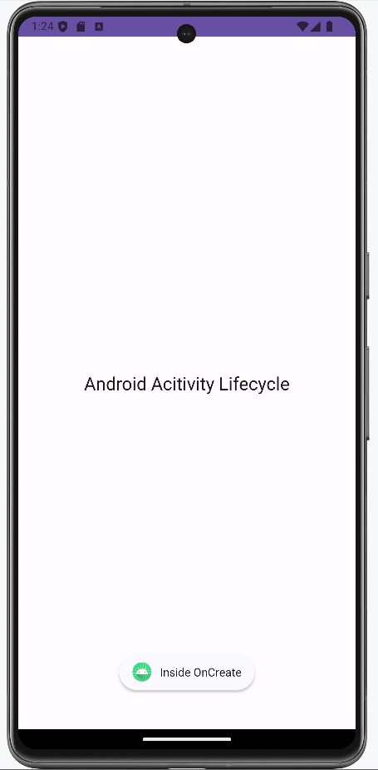 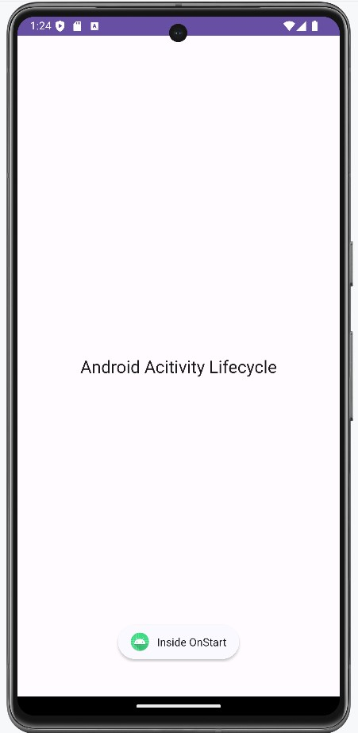

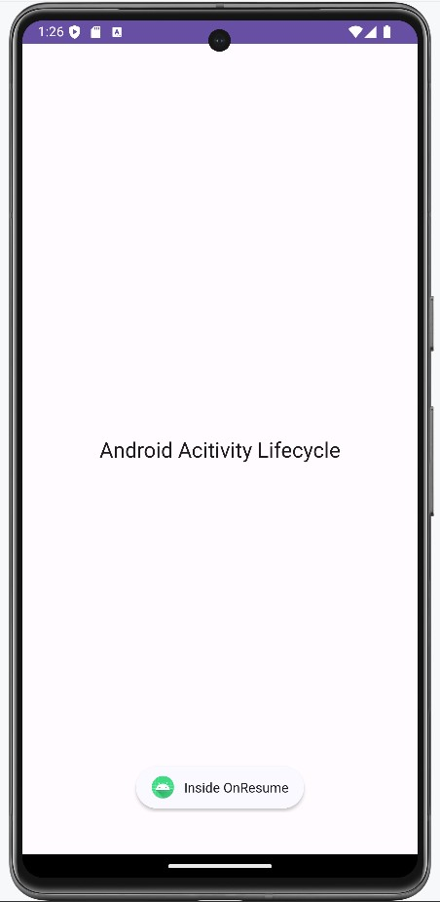 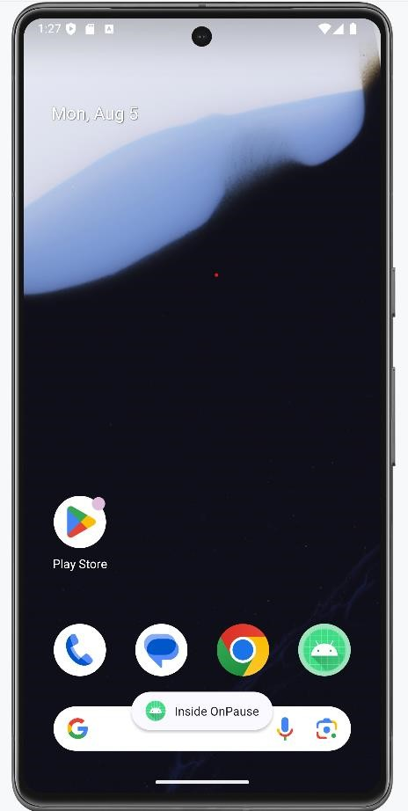

**Assignment 2**

Aim: Implement Addition of Two Numbers.

CODE:

*MainActivity.java* package com.example.myapplication;

import androidx.appcompat.app.AppCompatActivity;

import android.os.Bundle; import android.view.View; import android.widget.Button; import android.widget.EditText; import android.widget.TextView;

public class MainActivity extends AppCompatActivity {

@Override protected void onCreate(Bundle savedInstanceState) { super.onCreate(savedInstanceState); setContentView(R.layout.activity_main);

EditText num1,num2;

TextView output;

Button button ;

num1 = findViewById(R.id.num1); num2 = findViewById(R.id.num2); output = findViewById(R.id.output); button = findViewById(R.id.button); button.setOnClickListener(new View.OnClickListener() {

@Override public void onClick(View v) { int n1 = Integer.parseInt(num1.getText().toString()); int n2 = Integer.parseInt(num2.getText().toString());

int res = n1 + n2;

output.setText("Result is " + String.valueOf(res));

}

});

}

}

# activity_main.xml

<?xml version="1.0" encoding="utf-8"?>

<androidx.constraintlayout.widget.ConstraintLayout xmlns:android="http://schemas.android.com/apk/res/android" xmlns:app="http://schemas.android.com/apk/res-auto" xmlns:tools="http://schemas.android.com/tools" android:layout_width="match_parent" android:layout_height="match_parent" tools:context=".MainActivity">

<EditText android:id="@+id/num2" android:layout_width="156dp" android:layout_height="48dp" android:ems="10" android:hint="@string/enter_number_2" android:inputType="numberSigned" app:layout_constraintBottom_toBottomOf="parent" app:layout_constraintEnd_toEndOf="parent" app:layout_constraintHorizontal_bias="0.874" app:layout_constraintStart_toStartOf="parent" app:layout_constraintTop_toTopOf="parent" app:layout_constraintVertical_bias="0.402" />

<TextView android:id="@+id/logoAddition" android:layout_width="155dp" android:layout_height="54dp" android:text="Addition " android:textSize="40dp" app:layout_constraintBottom_toBottomOf="parent" app:layout_constraintEnd_toEndOf="parent" app:layout_constraintHorizontal_bias="0.496" app:layout_constraintStart_toStartOf="parent" app:layout_constraintTop_toTopOf="parent" app:layout_constraintVertical_bias="0.124" android:textColor="@color/blue"

/>

<Button android:id="@+id/button" android:layout_width="wrap_content" android:layout_height="wrap_content" android:text="@string/button" app:layout_constraintBottom_toBottomOf="parent" app:layout_constraintEnd_toEndOf="parent" app:layout_constraintStart_toStartOf="parent" app:layout_constraintTop_toTopOf="parent" app:layout_constraintVertical_bias="0.734" />

<EditText android:id="@+id/num1" android:layout_width="156dp" android:layout_height="48dp" android:layout_marginTop="204dp" android:layout_marginEnd="32dp" android:ems="10" android:hint="@string/enter_number_1" android:inputType="numberSigned" app:layout_constraintEnd_toEndOf="parent" app:layout_constraintTop_toTopOf="parent" /> <TextView android:id="@+id/output"

android:layout_width="156dp"

android:layout_height="32dp" android:layout_marginBottom="72dp"

android:text=""

app:layout_constraintBottom_toTopOf="@+id/button" app:layout_constraintEnd_toEndOf="parent" app:layout_constraintHorizontal_bias="0.494" app:layout_constraintStart_toStartOf="parent" app:layout_constraintTop_toTopOf="parent" app:layout_constraintVertical_bias="1.0" />

<TextView android:id="@+id/num1txt" android:layout_width="112dp" android:layout_height="37dp" android:layout_marginEnd="72dp" android:text="@string/enter_number_1txt" app:layout_constraintBottom_toBottomOf="parent" app:layout_constraintEnd_toStartOf="@+id/num1" app:layout_constraintHorizontal_bias="0.769" app:layout_constraintStart_toStartOf="parent" app:layout_constraintTop_toTopOf="parent" app:layout_constraintVertical_bias="0.311" /> <TextView android:id="@+id/num2txt" android:layout_width="113dp"

android:layout_height="34dp" android:layout_marginEnd="72dp" android:text="@string/enter_number_2txt" app:layout_constraintBottom_toBottomOf="parent" app:layout_constraintEnd_toStartOf="@+id/num2" app:layout_constraintHorizontal_bias="0.789" app:layout_constraintStart_toStartOf="parent" app:layout_constraintTop_toTopOf="parent" app:layout_constraintVertical_bias="0.414" />

</androidx.constraintlayout.widget.ConstraintLayout>

OUTPUT:

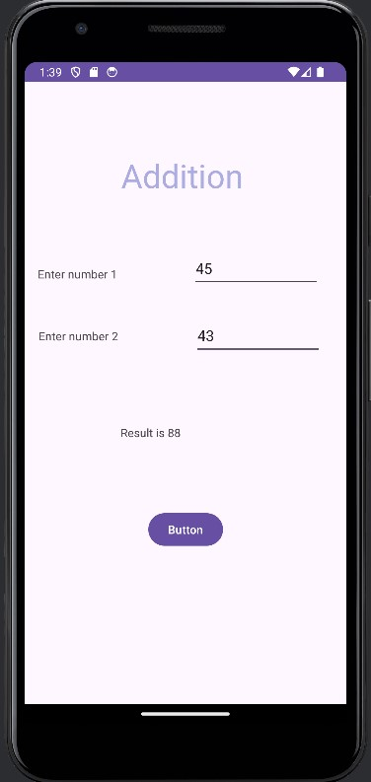

**Assignment 3**

Aim: Implementation of BMI Calculator.

CODE:

*MainActivity.java* package com.example.bmicalculator;

import android.os.Bundle; import android.view.View; import android.widget.Button; import android.widget.EditText; import android.widget.TextView;

import androidx.activity.EdgeToEdge; import androidx.appcompat.app.AppCompatActivity; import androidx.core.graphics.Insets; import androidx.core.view.ViewCompat; import androidx.core.view.WindowInsetsCompat;

public class MainActivity extends AppCompatActivity {

@Override protected void onCreate(Bundle savedInstanceState) { super.onCreate(savedInstanceState); EdgeToEdge.enable(this); setContentView(R.layout.activity_main);

EditText edtWeight = findViewById(R.id.weight);

EditText edtHeight = findViewById(R.id.height);

Button btn = findViewById(R.id.calc);

TextView txtView = findViewById(R.id.result);

btn.setOnClickListener(new View.OnClickListener() {

@Override public void onClick(View view) { float height = Float.parseFloat(String.valueOf(edtHeight.getText()))/100; //in cms float weight = Float.parseFloat(String.valueOf(edtWeight.getText())); float bmi=weight/(height*height) ; //in cms txtView.setText(String.valueOf(bmi));

}

});

}

}

# activity_main.xml

<?xml version="1.0" encoding="utf-8"?>

<androidx.constraintlayout.widget.ConstraintLayout xmlns:android="http://schemas.android.com/apk/res/android" xmlns:app="http://schemas.android.com/apk/res-auto" xmlns:tools="http://schemas.android.com/tools" android:id="@+id/main" android:layout_width="match_parent" android:layout_height="match_parent" android:gravity="center" tools:context=".MainActivity">

<TextView android:id="@+id/bmi" android:layout_width="179dp" android:layout_height="55dp" android:layout_marginStart="157dp" android:layout_marginTop="70dp" android:layout_marginEnd="196dp" android:layout_marginBottom="642dp" android:text="BMI Calculator" android:textSize="25dp" android:textStyle="bold" android:gravity="center"

app:layout_constraintBottom_toBottomOf="parent" app:layout_constraintEnd_toEndOf="parent" app:layout_constraintHorizontal_bias="0.471" app:layout_constraintStart_toStartOf="parent" app:layout_constraintTop_toTopOf="parent" app:layout_constraintVertical_bias="0.527" />

<EditText android:id="@+id/weight" android:layout_width="wrap_content" android:layout_height="wrap_content" android:layout_marginStart="81dp"

android:layout_marginTop="16dp" android:layout_marginEnd="120dp" android:layout_marginBottom="564dp" android:ems="10" android:hint="Enter your weight"

android:inputType="number" app:layout_constraintBottom_toBottomOf="parent" app:layout_constraintEnd_toEndOf="parent" app:layout_constraintStart_toStartOf="parent" app:layout_constraintTop_toBottomOf="@+id/bmi" />

<EditText android:id="@+id/height" android:layout_width="wrap_content" android:layout_height="wrap_content" android:layout_marginStart="83dp" android:layout_marginTop="23dp" android:layout_marginEnd="118dp" android:layout_marginBottom="496dp" android:ems="10" android:hint="Enter your height" android:inputType="number" app:layout_constraintBottom_toBottomOf="parent" app:layout_constraintEnd_toEndOf="parent" app:layout_constraintStart_toStartOf="parent" app:layout_constraintTop_toBottomOf="@+id/weight" />

<Button

android:id="@+id/calc" android:layout_width="wrap_content" android:layout_height="wrap_content" android:layout_marginStart="149dp"

android:layout_marginTop="55dp" android:layout_marginEnd="171dp" android:layout_marginBottom="393dp"

android:text="Calculate"

app:layout_constraintBottom_toBottomOf="parent" app:layout_constraintEnd_toEndOf="parent" app:layout_constraintHorizontal_bias="1.0" app:layout_constraintStart_toStartOf="parent" app:layout_constraintTop_toBottomOf="@+id/height" app:layout_constraintVertical_bias="0.0" />

<TextView android:id="@+id/result" android:layout_width="121dp" android:layout_height="22dp" android:layout_marginStart="167dp" android:layout_marginTop="50dp" android:layout_marginEnd="186dp" android:layout_marginBottom="324dp"

android:gravity="center" android:textSize="20dp" android:textStyle="bold"

app:layout_constraintBottom_toBottomOf="parent" app:layout_constraintEnd_toEndOf="parent" app:layout_constraintHorizontal_bias="0.682" app:layout_constraintStart_toStartOf="parent" app:layout_constraintTop_toBottomOf="@+id/calc"

app:layout_constraintVertical_bias="0.0" />

</androidx.constraintlayout.widget.ConstraintLayout>

OUTPUT:

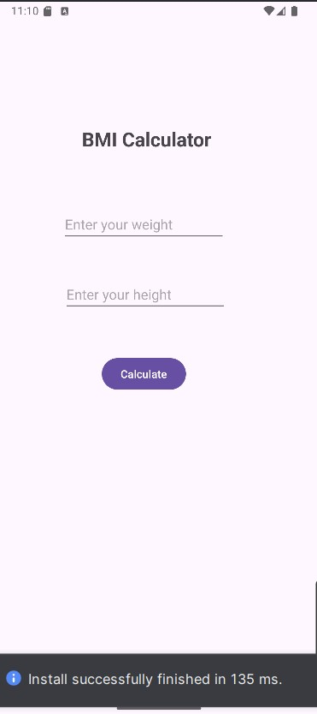 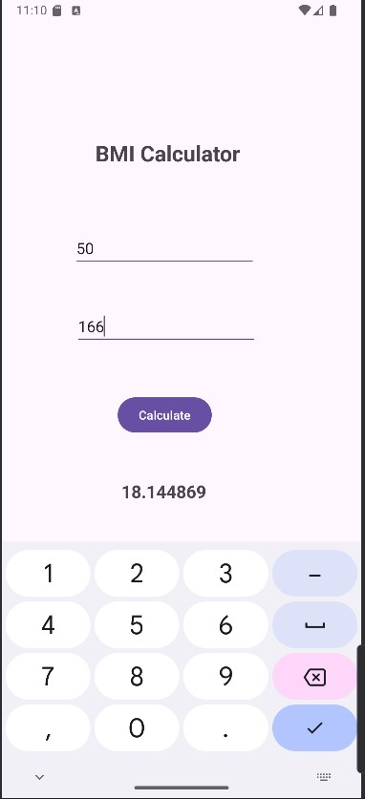

**Assignment 4**

Aim: Implementation of Currency Converter.

CODE:

*MainActivity.java* package com.example.currencyconveter_assignment3;

import androidx.appcompat.app.AppCompatActivity; import android.os.Bundle; import android.text.Editable; import android.text.TextWatcher; import android.view.View; import android.widget.AdapterView; import android.widget.ArrayAdapter; import android.widget.EditText; import android.widget.Spinner;

public class MainActivity extends AppCompatActivity {

Spinner sp1, sp2;

EditText inputAmount, outputAmount;

@Override protected void onCreate(Bundle savedInstanceState) { super.onCreate(savedInstanceState); setContentView(R.layout.activity_main);

sp1 = findViewById(R.id.Sp1); sp2 = findViewById(R.id.Sp2); inputAmount = findViewById(R.id.inputAmount); outputAmount = findViewById(R.id.outputAmount);

ArrayAdapter<CharSequence> ad = ArrayAdapter.createFromResource(this, R.array.countries, android.R.layout.simple_spinner_item); ad.setDropDownViewResource(android.R.layout.simple_spinner_dropdown_item);

sp1.setAdapter(ad);

ArrayAdapter<CharSequence> ad1 = ArrayAdapter.createFromResource(this, R.array.countries, android.R.layout.simple_spinner_item); ad1.setDropDownViewResource(android.R.layout.simple_spinner_dropdown_item);

sp2.setAdapter(ad1);

// Set default amount and perform initial conversion inputAmount.setText("1"); convertCurrency();

sp1.setOnItemSelectedListener(new AdapterView.OnItemSelectedListener() {

@Override

public void onItemSelected(AdapterView<?> parent, View view, int position, long id) {

convertCurrency();

}

@Override

public void onNothingSelected(AdapterView<?> parent) {}

});

sp2.setOnItemSelectedListener(new AdapterView.OnItemSelectedListener() { @Override

public void onItemSelected(AdapterView<?> parent, View view, int position, long id) {

convertCurrency();

}

@Override

public void onNothingSelected(AdapterView<?> parent) {}

});

inputAmount.addTextChangedListener(new TextWatcher() {

@Override public void beforeTextChanged(CharSequence s, int start, int count, int after) {}

@Override public void onTextChanged(CharSequence s, int start, int before, int count) {

convertCurrency();

}

@Override public void afterTextChanged(Editable s) {}

});

}

private void convertCurrency() {

String fromCurrency = sp1.getSelectedItem().toString();

String toCurrency = sp2.getSelectedItem().toString();

String inputText = inputAmount.getText().toString();

if (inputText.isEmpty()) { outputAmount.setText("");

return;

}

double amount = Double.parseDouble(inputText);

// Example conversion rates (You should replace these with actual rates or API calls) double conversionRate = getConversionRate(fromCurrency, toCurrency);

double convertedAmount = amount * conversionRate; outputAmount.setText(String.format("%.2f", convertedAmount));

}

// Method to get conversion rate based on selected currencies private double getConversionRate(String fromCurrency, String toCurrency) { double rate = 1.0; // Default rate is 1.0 for same currency

// Define conversion rates if (fromCurrency.equals("INR") && toCurrency.equals("GBP")) {

rate = 0.010;

} else if (fromCurrency.equals("GBP") && toCurrency.equals("INR")) {

rate = 100.0;

} else if (fromCurrency.equals("INR") && toCurrency.equals("PKR")) {

rate = 2.88;

} else if (fromCurrency.equals("PKR") && toCurrency.equals("INR")) {

rate = 1 / 2.88;

} else if (fromCurrency.equals("INR") && toCurrency.equals("CDF")) {

rate = 25.2;

} else if (fromCurrency.equals("CDF") && toCurrency.equals("INR")) {

rate = 1 / 25.2;

}

else if (fromCurrency.equals("USD") && toCurrency.equals("INR")) {

rate = 83;

}

else if (fromCurrency.equals("INR") && toCurrency.equals("USD")) {

rate = 0.012;

}

// Add more rates as needed

return rate;

}

}

# activity_main.xml

<?xml version="1.0" encoding="utf-8"?>

<RelativeLayout xmlns:android="http://schemas.android.com/apk/res/android" xmlns:app="http://schemas.android.com/apk/res-auto" xmlns:tools="http://schemas.android.com/tools" android:id="@+id/Main" android:layout_width="match_parent" android:layout_height="match_parent" tools:context=".MainActivity">

<Spinner android:id="@+id/Sp1" android:layout_width="346dp" android:layout_height="34dp" android:layout_below="@id/fromLbl" android:layout_alignParentStart="true" android:layout_alignParentEnd="true" android:layout_marginStart="37dp" android:layout_marginTop="-14dp" android:layout_marginEnd="28dp" tools:layout_editor_absoluteX="33dp" tools:layout_editor_absoluteY="166dp" />

<Spinner

android:id="@+id/Sp2"

android:layout_width="346dp" android:layout_height="34dp" android:layout_below="@id/toLbl" android:layout_alignParentStart="true" android:layout_alignParentEnd="true" android:layout_marginStart="30dp" android:layout_marginTop="25dp" android:layout_marginEnd="34dp" />

<TextView android:id="@+id/Lable1" android:layout_width="206dp" android:layout_height="34dp" android:layout_alignParentStart="true" android:layout_alignParentTop="true" android:layout_alignParentEnd="true" android:layout_marginStart="103dp" android:layout_marginTop="46dp" android:layout_marginEnd="102dp" android:text="Currency Conveter" android:textSize="24sp" />

<TextView android:id="@+id/fromLbl" android:layout_width="57dp" android:layout_height="30dp" android:layout_below="@id/Lable1" android:layout_alignParentStart="true" android:layout_alignParentEnd="true" android:layout_marginStart="18dp" android:layout_marginTop="33dp" android:layout_marginEnd="334dp"

android:hint="From" android:textSize="16sp" />

<TextView android:id="@+id/toLbl" android:layout_width="wrap_content" android:layout_height="wrap_content" android:layout_below="@id/Sp1" android:layout_alignParentStart="true" android:layout_alignParentEnd="true" android:layout_marginStart="28dp" android:layout_marginTop="56dp" android:layout_marginEnd="354dp"

android:hint="To" android:textSize="16sp" />

<EditText

android:id="@+id/inputAmount" android:layout_width="346dp" android:layout_height="wrap_content" android:layout_below="@id/fromLbl" android:layout_alignParentStart="true" android:layout_marginStart="34dp" android:layout_marginTop="32dp" android:layout_marginEnd="28dp" android:hint="1" android:inputType="numberDecimal" />

<EditText

android:id="@+id/outputAmount" android:layout_width="346dp" android:layout_height="wrap_content" android:layout_below="@id/Sp2" android:layout_alignParentStart="true" android:layout_marginStart="42dp" android:layout_marginTop="28dp" android:layout_marginEnd="28dp" android:focusable="false" android:hint="Converted amount" android:inputType="none" />

<TextView android:id="@+id/ans" android:layout_width="271dp" android:layout_height="69dp" android:layout_below="@id/Sp2" android:layout_alignParentStart="true" android:layout_alignParentEnd="true" android:layout_marginStart="71dp" android:layout_marginTop="93dp" android:layout_marginEnd="69dp" />

</RelativeLayout>

# strings.xml

<resources>

<string name="app_name">CurrencyConveter_assignment3</string>

<string-array name="countries">

<item>INR</item>

<item>GBP</item>

<item>PKR</item> <item>CDF</item>

<item>USD</item>

</string-array>

</resources>

OUTPUT:

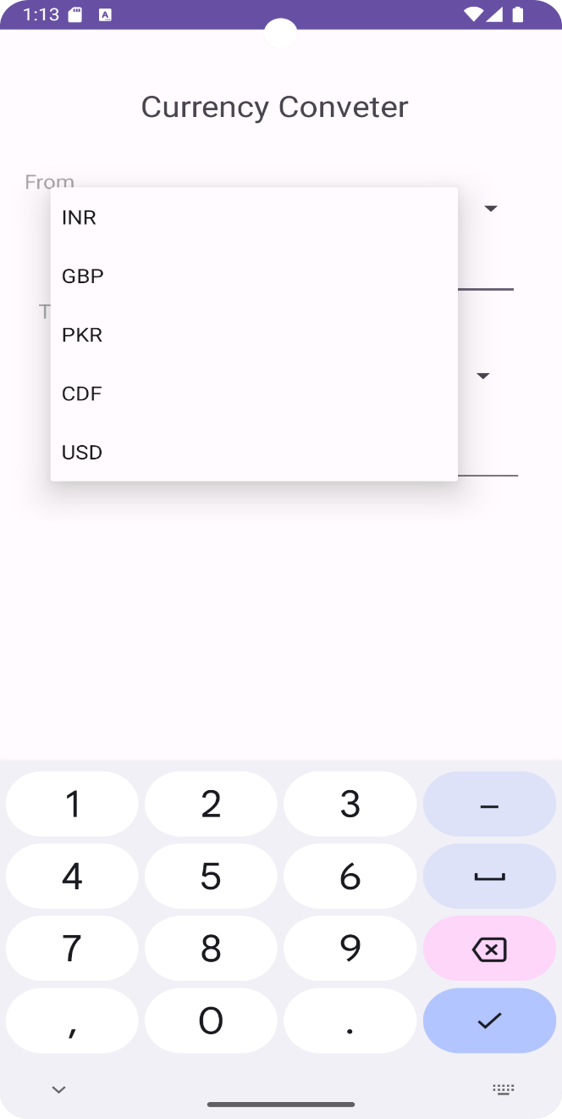 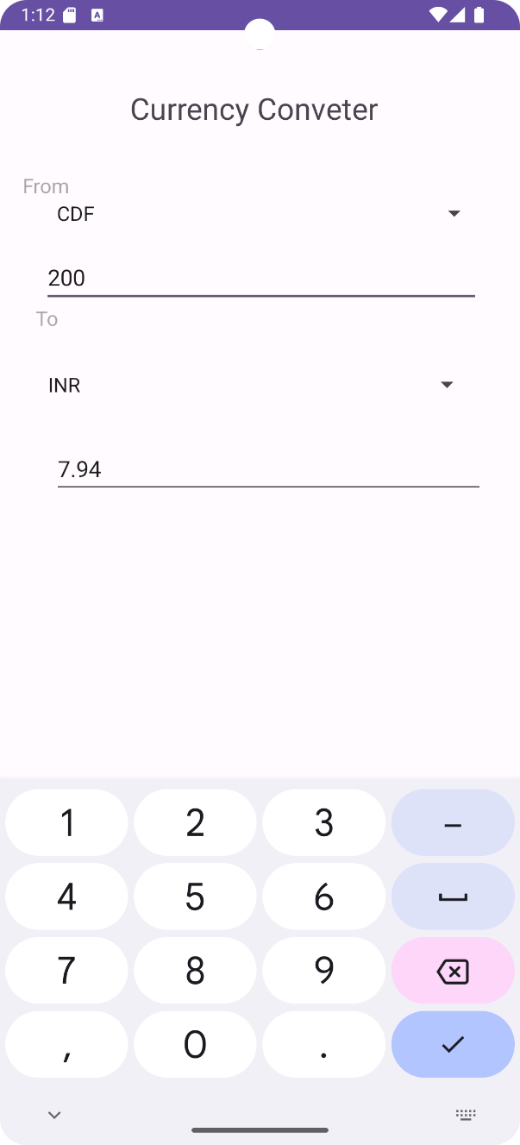

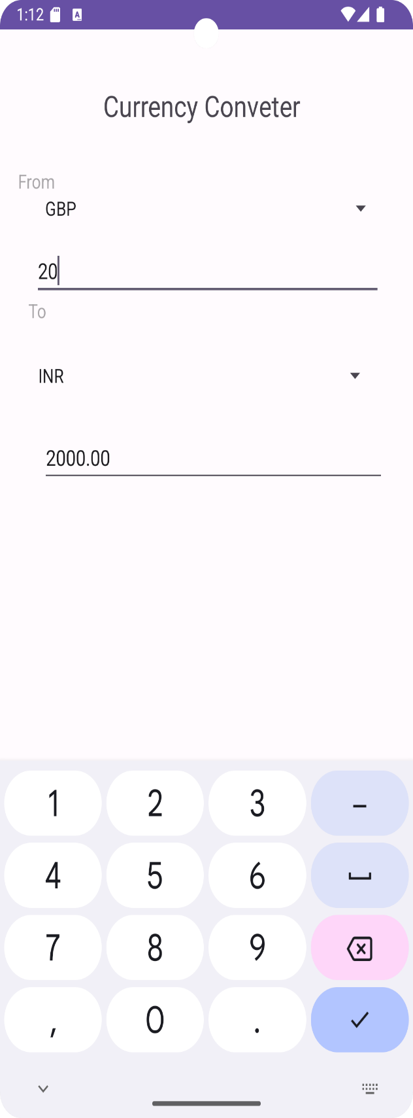 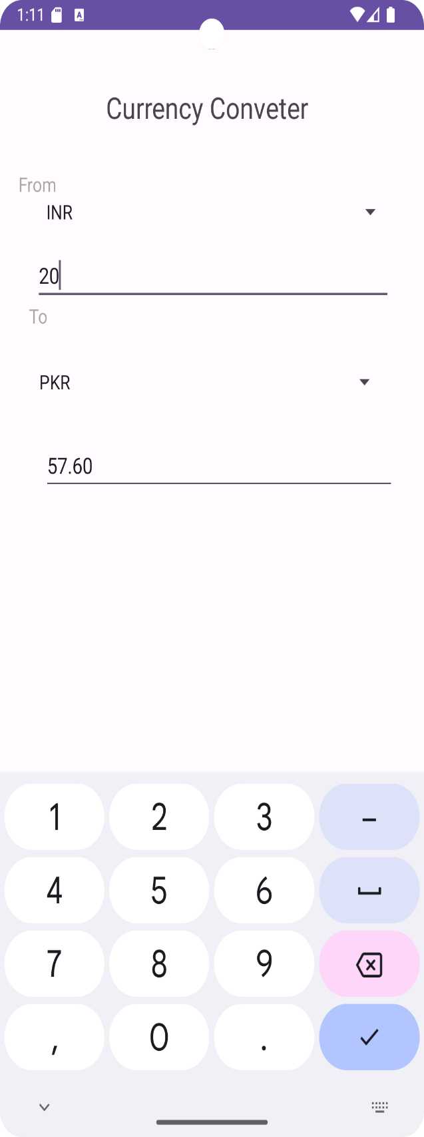

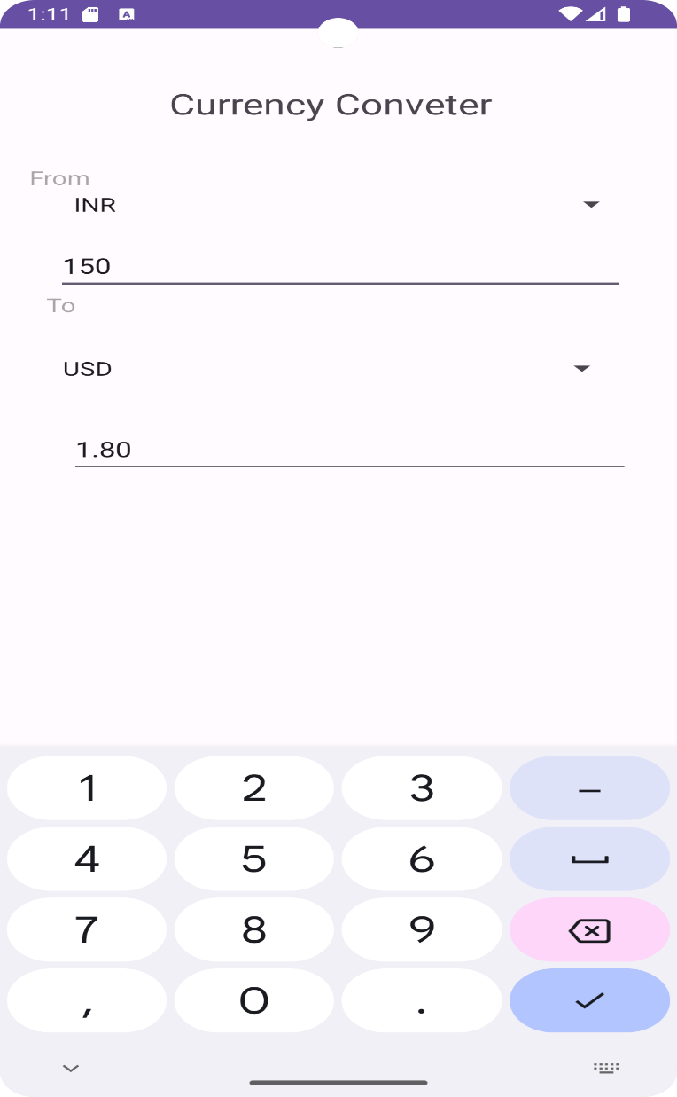

**Assignment 5**

Aim: Implementation of Simple Calculator.

CODE:

*MainActivity.java* package com.example.simplecalculator;

import android.os.Bundle; import android.widget.Button; import android.widget.TextView;

import androidx.activity.EdgeToEdge; import androidx.appcompat.app.AppCompatActivity; import androidx.core.graphics.Insets; import androidx.core.view.ViewCompat; import androidx.core.view.WindowInsetsCompat;

import java.util.ArrayList;

public class MainActivity extends AppCompatActivity {

double firstNum;

String operation;

@Override protected void onCreate(Bundle savedInstanceState) { super.onCreate(savedInstanceState); setContentView(R.layout.activity_main);

Button num0=findViewById(R.id.num0);

Button num1=findViewById(R.id.num1);

Button num2=findViewById(R.id.num2);

Button num3=findViewById(R.id.num3);

Button num4=findViewById(R.id.num4);

Button num5=findViewById(R.id.num5);

Button num6=findViewById(R.id.num6);

Button num7=findViewById(R.id.num7);

Button num8=findViewById(R.id.num8); Button num9=findViewById(R.id.num9);

Button on = findViewById(R.id.on);

Button off = findViewById(R.id.off);

Button ac = findViewById(R.id.ac);

Button del = findViewById(R.id.del);

Button div = findViewById(R.id.div);

Button mul = findViewById(R.id.mul);

Button sub = findViewById(R.id.sub);

Button add = findViewById(R.id.add);

Button equal = findViewById(R.id.equal);

Button point = findViewById(R.id.point);

TextView screen = findViewById(R.id.screen);

ac.setOnClickListener(view -> { firstNum=0; screen.setText("0");

});

off.setOnClickListener(view ->screen.setVisibility(TextView.GONE)); on.setOnClickListener(view->{ screen.setVisibility(TextView.VISIBLE); screen.setText("0");

});

ArrayList<Button>nums = new ArrayList<>(); nums.add(num0); nums.add(num1); nums.add(num2); nums.add(num3); nums.add(num4); nums.add(num5); nums.add(num6); nums.add(num7); nums.add(num8); nums.add(num9);

for(Button b:nums){

b.setOnClickListener(view -> { if(!screen.getText().toString().equals("0")){ screen.setText(screen.getText().toString()+b.getText().toString());

}

else{

screen.setText(b.getText().toString());

}

});

}

ArrayList<Button>opers=new ArrayList<>();

opers.add(div); opers.add(mul); opers.add(sub); opers.add(add); for(Button b:opers){

b.setOnClickListener(view -> { firstNum=Double.parseDouble(screen.getText().toString()); operation=b.getText().toString(); screen.setText("0");

});

}

del.setOnClickListener(view -> { String num=screen.getText().toString(); if(num.length()>1){ screen.setText(num.substring(0,num.length()-1));

}

else if(num.length()==1&&!num.equals("0")){

screen.setText("0");

}

});

point.setOnClickListener(view -> { if(!screen.getText().toString().contains(".")){ screen.setText(screen.getText().toString()+".");

}

});

equal.setOnClickListener(view -> { double secondNum=Double.parseDouble(screen.getText().toString());

double result; switch(operation){

case "/":

result=firstNum/secondNum;

break;

case "x":

result=firstNum*secondNum;

break;

case "+":

result=firstNum+secondNum;

break;

case "-":

result=firstNum-secondNum;

break;

default:

result=firstNum+secondNum;

}

screen.setText(String.valueOf(result)); firstNum=result;

});

}

}

*activity_main.xml* package com.example.simplecalculator;

import android.os.Bundle; import android.widget.Button; import android.widget.TextView;

import androidx.activity.EdgeToEdge; import androidx.appcompat.app.AppCompatActivity; import androidx.core.graphics.Insets; import androidx.core.view.ViewCompat; import androidx.core.view.WindowInsetsCompat;

import java.util.ArrayList;

public class MainActivity extends AppCompatActivity {

double firstNum;

String operation;

@Override protected void onCreate(Bundle savedInstanceState) { super.onCreate(savedInstanceState); setContentView(R.layout.activity_main);

Button num0=findViewById(R.id.num0);

Button num1=findViewById(R.id.num1);

Button num2=findViewById(R.id.num2);

Button num3=findViewById(R.id.num3);

Button num4=findViewById(R.id.num4);

Button num5=findViewById(R.id.num5);

Button num6=findViewById(R.id.num6);

Button num7=findViewById(R.id.num7);

Button num8=findViewById(R.id.num8); Button num9=findViewById(R.id.num9);

Button on = findViewById(R.id.on);

Button off = findViewById(R.id.off);

Button ac = findViewById(R.id.ac);

Button del = findViewById(R.id.del);

Button div = findViewById(R.id.div);

Button mul = findViewById(R.id.mul);

Button sub = findViewById(R.id.sub);

Button add = findViewById(R.id.add);

Button equal = findViewById(R.id.equal);

Button point = findViewById(R.id.point);

TextView screen = findViewById(R.id.screen);

ac.setOnClickListener(view -> { firstNum=0; screen.setText("0");

});

off.setOnClickListener(view ->screen.setVisibility(TextView.GONE));

on.setOnClickListener(view->{

screen.setVisibility(TextView.VISIBLE); screen.setText("0");

});

ArrayList<Button>nums = new ArrayList<>(); nums.add(num0); nums.add(num1); nums.add(num2); nums.add(num3); nums.add(num4); nums.add(num5); nums.add(num6); nums.add(num7); nums.add(num8); nums.add(num9);

for(Button b:nums){

b.setOnClickListener(view -> { if(!screen.getText().toString().equals("0")){ screen.setText(screen.getText().toString()+b.getText().toString());

}

else{

screen.setText(b.getText().toString());

}

});

}

ArrayList<Button>opers=new ArrayList<>();

opers.add(div); opers.add(mul); opers.add(sub); opers.add(add); for(Button b:opers){

b.setOnClickListener(view -> { firstNum=Double.parseDouble(screen.getText().toString()); operation=b.getText().toString(); screen.setText("0");

});

}

del.setOnClickListener(view -> { String num=screen.getText().toString(); if(num.length()>1){ screen.setText(num.substring(0,num.length()-1));

}

else if(num.length()==1&&!num.equals("0")){

screen.setText("0");

}

});

point.setOnClickListener(view -> { if(!screen.getText().toString().contains(".")){ screen.setText(screen.getText().toString()+"."); }

});

equal.setOnClickListener(view -> { double secondNum=Double.parseDouble(screen.getText().toString());

double result; switch(operation){

case "/":

result=firstNum/secondNum;

break;

case "x":

result=firstNum*secondNum;

break;

case "+":

result=firstNum+secondNum;

break;

case "-":

result=firstNum-secondNum;

break;

default:

result=firstNum+secondNum;

}

screen.setText(String.valueOf(result));

firstNum=result;

});

}

}

OUTPUT:

Addition

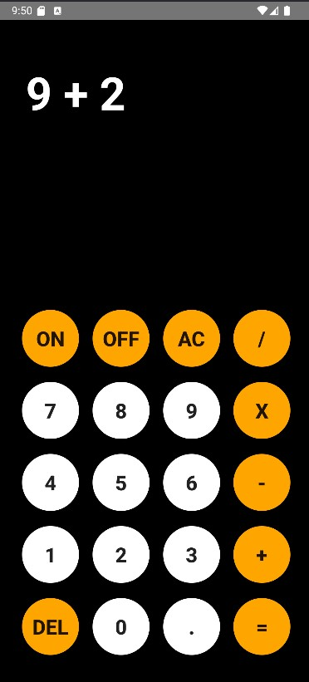 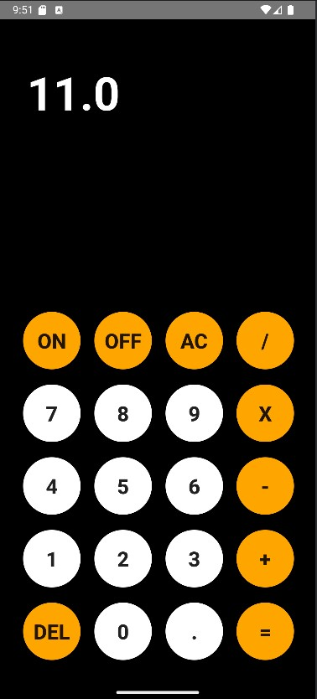

Subtraction:

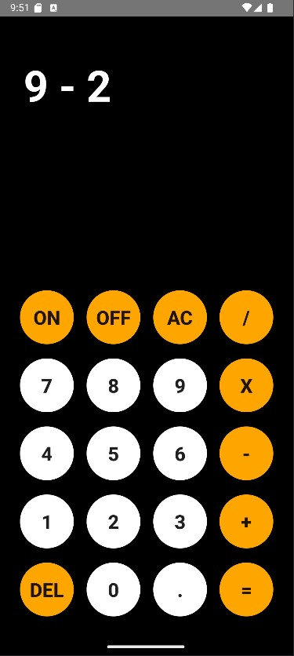 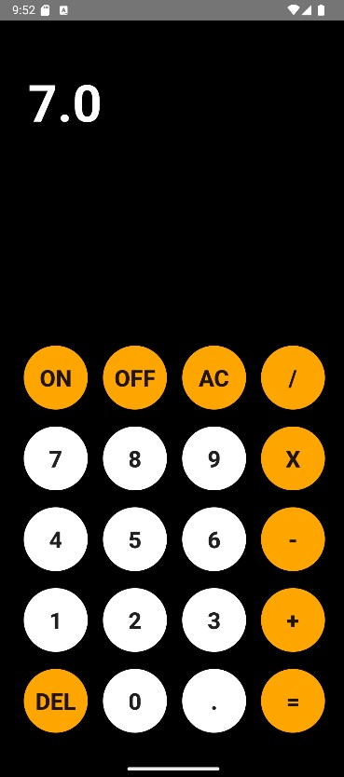

Multiplication

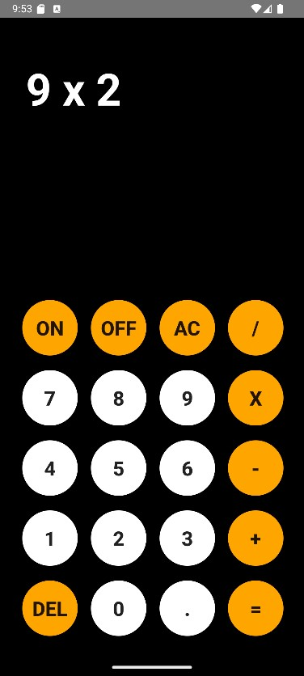 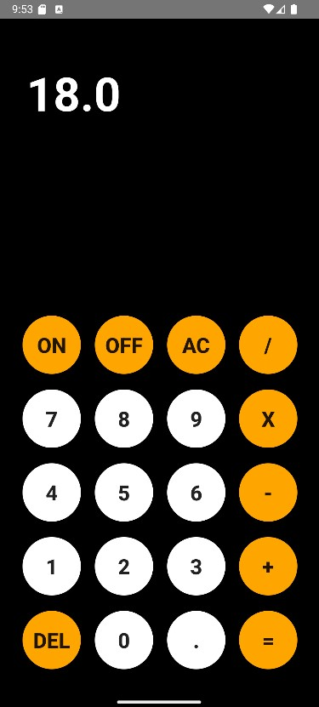

Division

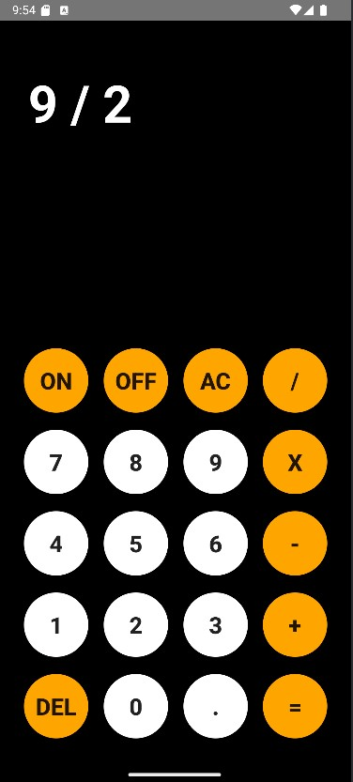 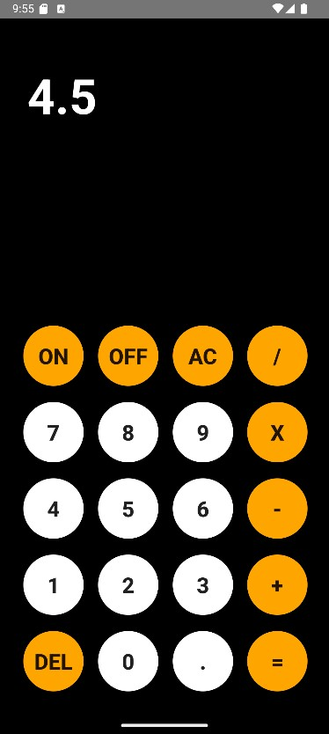

**Assignment 6**

Aim: Create a registration form using basic UI components and show the entered values in another activity of the same application.

CODE:

# MainActivity.java

package com.example.regiformintent;

import android.content.Intent; import android.os.Bundle; import android.view.View; import android.widget.Button; import android.widget.EditText; import android.widget.RadioButton;

import android.widget.RadioGroup;

import androidx.activity.EdgeToEdge;

import androidx.appcompat.app.AppCompatActivity;

public class MainActivity extends AppCompatActivity {

EditText name, password, mobile;

Button submit;

RadioGroup genderGroup;

RadioButton selectedGender;

@Override

protected void onCreate(Bundle savedInstanceState) {

super.onCreate(savedInstanceState); EdgeToEdge.enable(this);

setContentView(R.layout.activity_main);

submit=findViewById(R.id.submit); name=findViewById(R.id.name); password=findViewById(R.id.password); mobile=findViewById(R.id.mobile);

genderGroup=findViewById(R.id.genderrd);

submit.setOnClickListener(new View.OnClickListener() {

@Override

public void onClick(View view) { String n = name.getText().toString();

String p = password.getText().toString();

String m = mobile.getText().toString();

int id = genderGroup.getCheckedRadioButtonId(); selectedGender=findViewById(id);

String g =selectedGender.getText().toString();

Intent intent = new Intent(MainActivity.this,DisplayActivity.class); intent.putExtra("nameUser",n); intent.putExtra("mobileUser",m); intent.putExtra("passwordUser",p);

intent.putExtra("gender",g);

startActivity(intent);

}

});

}

}

# DisplayActivity.java

package com.example.regiformintent;

import android.os.Bundle;

import android.widget.TextView;

import androidx.activity.EdgeToEdge; import androidx.appcompat.app.AppCompatActivity;

import androidx.core.graphics.Insets; import androidx.core.view.ViewCompat;

import androidx.core.view.WindowInsetsCompat;

public class DisplayActivity extends AppCompatActivity {

TextView name , password,mobile,gender;

@Override

protected void onCreate(Bundle savedInstanceState) {

super.onCreate(savedInstanceState); EdgeToEdge.enable(this);

setContentView(R.layout.activity_display);

name = findViewById(R.id.nameview); password = findViewById(R.id.passwordview); mobile= findViewById(R.id.phoneview);

gender = findViewById(R.id.genderview);

String username = getIntent().getStringExtra("nameUser");

String userpassword = getIntent().getStringExtra("passwordUser");

String usermobile = getIntent().getStringExtra("mobileUser");

String usergender = getIntent().getStringExtra("gender");

name.setText(username); password.setText(userpassword); mobile.setText(usermobile);

gender.setText(usergender);

}

}

OUTPUT:

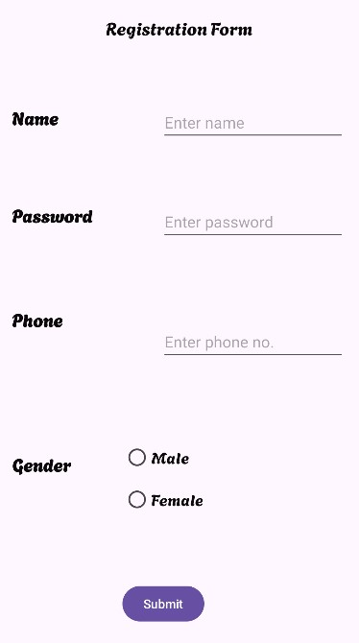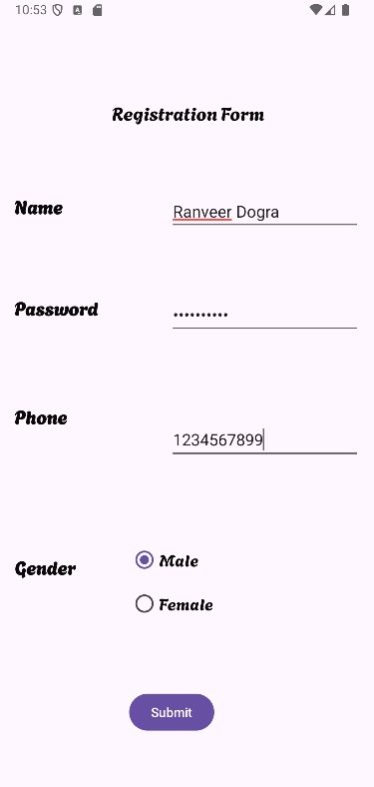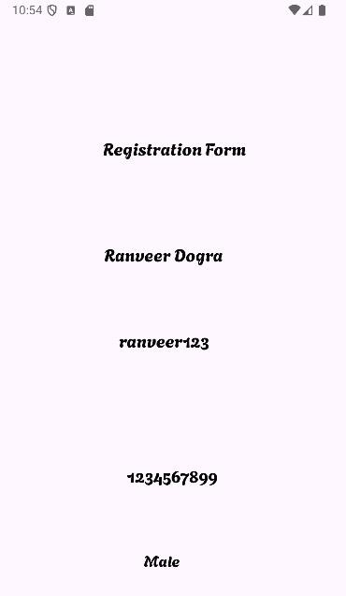

**Assignment 7**

Aim: Use implicit Intent and perform the following operations:

1. Visit any Website
2. Dial any number
3. Share text message
4. Send a SMS
5. Send an E-mail
6. Share data with another application CODE:

# MainActivity.java

package com.example.intent;

import android.content.ActivityNotFoundException; import android.content.Intent; import android.net.Uri; import android.os.Bundle; import android.view.View; import android.widget.Button; import android.widget.EditText; import android.widget.TextView;

import android.widget.Toast;

import androidx.activity.EdgeToEdge; import androidx.appcompat.app.AppCompatActivity;

import androidx.core.graphics.Insets; import androidx.core.view.ViewCompat;

import androidx.core.view.WindowInsetsCompat;

public class MainActivity extends AppCompatActivity {

String val;

@Override

protected void onCreate(Bundle savedInstanceState) { super.onCreate(savedInstanceState);

setContentView(R.layout.activity_main);

EditText edttext;

Button btnview, btndial, btnshare, btnsendto, btnemail, btnswitchapp;

edttext=findViewById(R.id.edttext); btnview=findViewById(R.id.btnview); btndial=findViewById(R.id.btndial); btnshare=findViewById(R.id.btnshare); btnsendto=findViewById(R.id.btnsendto); btnemail=findViewById(R.id.btnemail);

btnswitchapp=findViewById(R.id.btnswitchapp);

btnview.setOnClickListener(new View.OnClickListener() {

@Override

public void onClick(View view) { val=edttext.getText().toString(); Intent iview=new Intent(); iview.setAction(Intent.ACTION_VIEW); iview.setData(Uri.parse(val));

Intent.createChooser(iview,"Choose the Browser type: "); startActivity(iview);

}

});

btndial.setOnClickListener(new View.OnClickListener() {

@Override

public void onClick(View view) { Intent idial=new Intent(); idial.setAction(Intent.ACTION_DIAL); idial.setData(Uri.parse("tel: +91 7364912465")); startActivity(idial);

}

});

btnshare.setOnClickListener(new View.OnClickListener() {

@Override

public void onClick(View view) { Intent ishare=new Intent(); ishare.setAction(Intent.ACTION_SEND);

ishare.putExtra(Intent.EXTRA_TEXT,"Good Morning Ranveer! Have a nice Wonderful Day:)");

ishare.setType("text/plain");

startActivity(ishare);

}

});

btnsendto.setOnClickListener(new View.OnClickListener() {

@Override

public void onClick(View view) { Intent isendto=new Intent();

isendto.setAction(Intent.ACTION_SENDTO); isendto.setData(Uri.parse("smsto: +91 7364912465"));

isendto.putExtra("sms_body","Kya re placement hogaya toh bada hogya kya:)"); startActivity(isendto);

}

});

btnemail.setOnClickListener(new View.OnClickListener() {

@Override

public void onClick(View view) {

Intent iemail = new Intent(Intent.ACTION_SEND); iemail.setType("message/rfc822");

iemail.putExtra(Intent.EXTRA_EMAIL, new String[]{"ranveerdogra11@gmail.com"}); iemail.putExtra(Intent.EXTRA_SUBJECT, "Campus Placement"); iemail.putExtra(Intent.EXTRA_TEXT, "You need to WORK HARD!!");

try {

startActivity(Intent.createChooser(iemail, "Choose an email client:"));

} catch (ActivityNotFoundException e) {

Toast.makeText(MainActivity.this, "No email client installed.",

Toast.LENGTH_SHORT).show();

}

}

});

btnswitchapp.setOnClickListener(new View.OnClickListener() {

@Override

public void onClick(View view) { Intent iswitch=new Intent(); iswitch.setAction(Intent.ACTION_SEND);

iswitch.putExtra(Intent.EXTRA_TEXT,"GOOD MORNING! "); iswitch.setType("text/plain"); startActivity(iswitch);

}

});

}

}

**MAKE ANOTHER PROJECT FOR SWITCHING APP**

# MainActivity.java

package com.example.receive;

import android.content.Intent; import android.os.Bundle;

import android.widget.TextView;

import androidx.activity.EdgeToEdge; import androidx.appcompat.app.AppCompatActivity;

import androidx.core.graphics.Insets; import androidx.core.view.ViewCompat;

import androidx.core.view.WindowInsetsCompat;

public class MainActivity extends AppCompatActivity {

@Override

protected void onCreate(Bundle savedInstanceState) { super.onCreate(savedInstanceState);

setContentView(R.layout.activity_main);

TextView txtmsg;

txtmsg = findViewById(R.id.txtmsg);

String val = getIntent().getStringExtra(Intent.EXTRA_TEXT); txtmsg.setText(val);

}

}

# AndroidManifest.xml

<?xml version="1.0" encoding="utf-8"?>

<manifest xmlns:android="http://schemas.android.com/apk/res/android" xmlns:tools="http://schemas.android.com/tools">

<application

android:allowBackup="true"

android:dataExtractionRules="@xml/data_extraction_rules" android:fullBackupContent="@xml/backup_rules" android:icon="@mipmap/ic_launcher" android:label="@string/app_name" android:roundIcon="@mipmap/ic_launcher_round"

android:supportsRtl="true" android:theme="@style/Theme.Receive"

tools:targetApi="31">

<activity

android:name=".MainActivity"

android:exported="true">

<intent-filter>

<action android:name="android.intent.action.SEND" />

<category android:name="android.intent.category.DEFAULT" />

<data android:mimeType="text/plain"/>

</intent-filter>

<intent-filter>

<action android:name="android.intent.action.MAIN" />

<category android:name="android.intent.category.LAUNCHER" />

</intent-filter>

</activity>

</application>

</manifest>

OUTPUT:

• Visit any Website 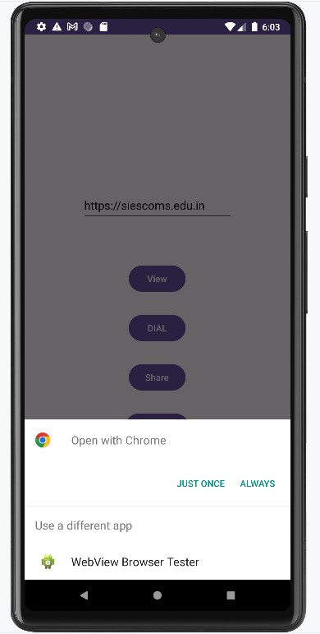 

## Dial any number

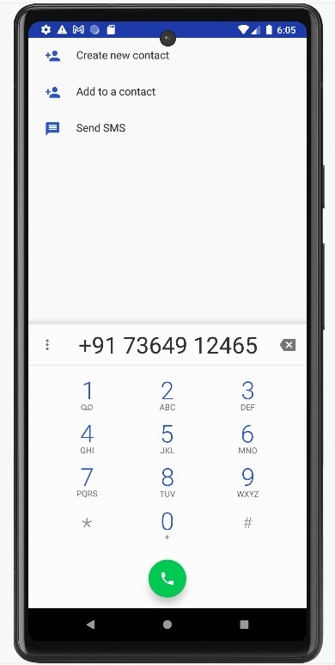

## Share text message

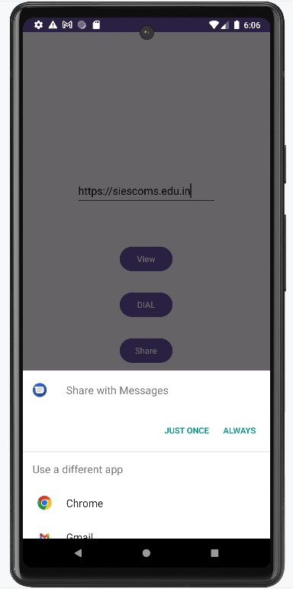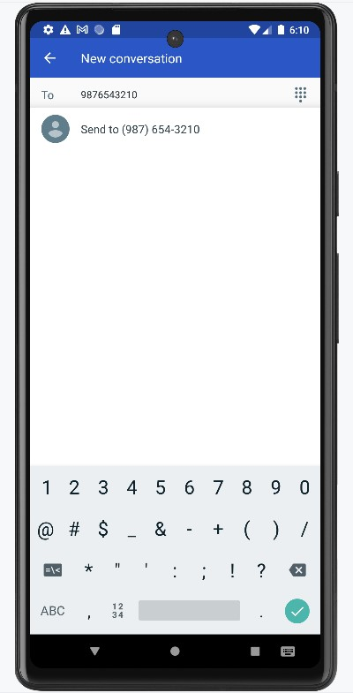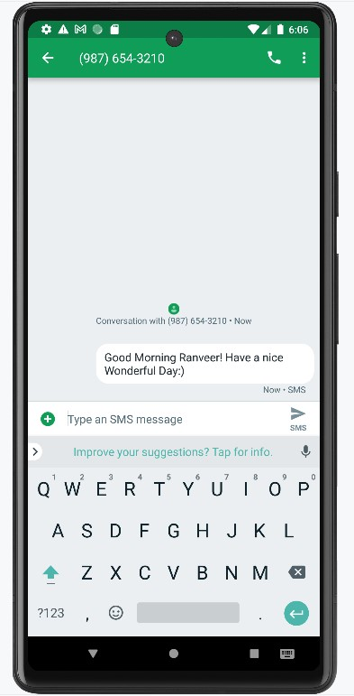

## Send a SMS

## Send an E-mail

## Share data with another application

*Make sure to run the other project before*

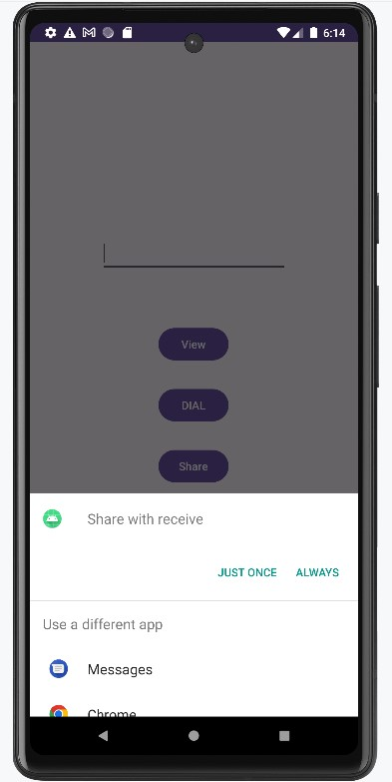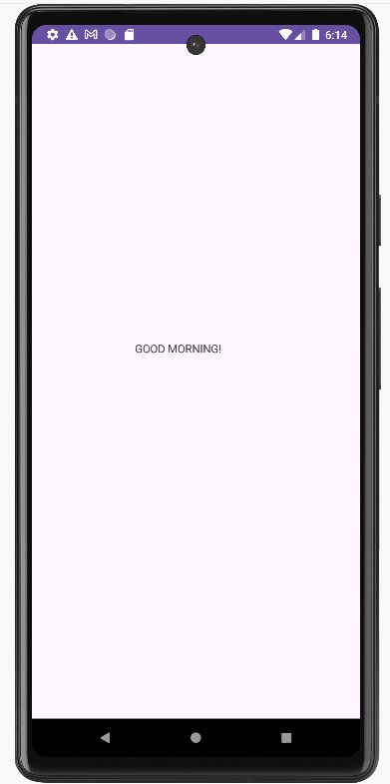

**Assignment 8**

Aim: Create an application that stores user login credentials using shared preferences. The app should start with a splash screen, and if the credentials are saved, it should automatically redirect to the user's home page. When the

"Remember Me" checkbox is selected during login, the credentials will be saved in shared preferences. On logout, the credentials should be cleared from shared preferences, securely logging the user out.

CODE:

*MainActivity.java*

package com.example.sharedpref;

import android.os.Bundle; import androidx.activity.EdgeToEdge;

import androidx.appcompat.app.AppCompatActivity;

import androidx.core.graphics.Insets; import androidx.core.view.ViewCompat; import androidx.core.view.WindowInsetsCompat;

import android.content.Intent; import android.content.SharedPreferences; import android.os.Bundle;

import android.os.Handler;

public class MainActivity extends AppCompatActivity {

private static final int SPLASH_DELAY = 3000; // 3 seconds

@Override

protected void onCreate(Bundle savedInstanceState) { super.onCreate(savedInstanceState);

setContentView(R.layout.activity_main);

new Handler().postDelayed(new Runnable() {

@Override public void run() {

SharedPreferences sharedPreferences = getSharedPreferences("LoginPrefs",

MODE_PRIVATE);

String username = sharedPreferences.getString("username", null);

String password = sharedPreferences.getString("password", null);

Intent intent;

if (username != null && password != null) { intent = new Intent(MainActivity.this, Home.class);

} else {

intent = new Intent(MainActivity.this, Login.class);

}

startActivity(intent);

finish();

}

}, SPLASH_DELAY);

}

}

*Login.java*

package com.example.sharedpref;

import android.content.Intent; import android.content.SharedPreferences; import android.os.Bundle; import android.view.View; import android.widget.Button; import android.widget.CheckBox; import android.widget.EditText; import android.widget.Toast;

import androidx.appcompat.app.AppCompatActivity;

public class Login extends AppCompatActivity {

private EditText edtEmail, edtPassword; private CheckBox chkRememberMe; private Button btnLogin;

private static final String VALID_EMAIL = "hello@demo.com"; private static final String VALID_PASSWORD = "noob@123";

@Override

protected void onCreate(Bundle savedInstanceState) { super.onCreate(savedInstanceState);

setContentView(R.layout.activity_login);

edtEmail = findViewById(R.id.edtEmail); edtPassword = findViewById(R.id.edtPassword); chkRememberMe = findViewById(R.id.chkRememberMe); btnLogin = findViewById(R.id.btnLogin);

SharedPreferences sharedPreferences = getSharedPreferences("LoginPrefs",

MODE_PRIVATE);

String savedEmail = sharedPreferences.getString("email", null);

String savedPassword = sharedPreferences.getString("password", null);

if (savedEmail != null && savedPassword != null) {

startActivity(new Intent(Login.this, Home.class)); finish();

}

btnLogin.setOnClickListener(new View.OnClickListener() {

@Override

public void onClick(View v) {

String email = edtEmail.getText().toString();

String password = edtPassword.getText().toString();

if (email.equals(VALID_EMAIL) && password.equals(VALID_PASSWORD)) { if (chkRememberMe.isChecked()) {

SharedPreferences.Editor editor = sharedPreferences.edit(); editor.putString("email", email);

editor.putString("password", password); editor.apply();

}

startActivity(new Intent(Login.this, Home.class)); finish(); } else {

Toast.makeText(Login.this, "Invalid credentials!", Toast.LENGTH_SHORT).show();

}

}

});

}

}

*Home.java*

package com.example.sharedpref;

import android.os.Bundle; import android.content.Intent; import android.content.SharedPreferences; import android.os.Bundle; import android.view.View; import android.widget.Button; import android.widget.TextView;

import androidx.appcompat.app.AppCompatActivity;

public class Home extends AppCompatActivity {

private TextView tvWelcome, tvEmail; private Button btnLogout;

@Override

protected void onCreate(Bundle savedInstanceState) { super.onCreate(savedInstanceState);

setContentView(R.layout.activity_home);

tvWelcome = findViewById(R.id.tvWelcome); tvEmail = findViewById(R.id.tvEmail);

btnLogout = findViewById(R.id.btnLogout);

SharedPreferences sharedPreferences = getSharedPreferences("LoginPrefs",

MODE_PRIVATE);

String email = sharedPreferences.getString("email", "N/A");

tvWelcome.setText("Welcome to Home Screen!"); tvEmail.setText("Logged in as: " + email);

btnLogout.setOnClickListener(new View.OnClickListener() {

@Override

public void onClick(View v) {

// Clear all login information

SharedPreferences.Editor editor = sharedPreferences.edit(); editor.clear();

editor.apply();

// Navigate back to Login screen

Intent intent = new Intent(Home.this, Login.class); intent.setFlags(Intent.FLAG_ACTIVITY_NEW_TASK | Intent.FLAG_ACTIVITY_CLEAR_TASK);

startActivity(intent);

finish();

}

});

}

}

OUTPUT:

Splash Screen Login Page 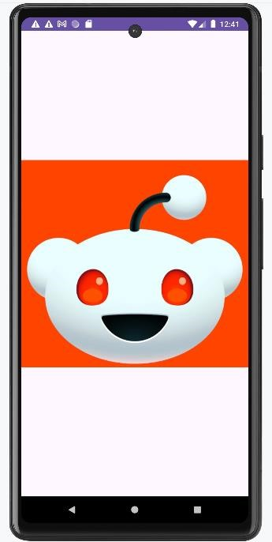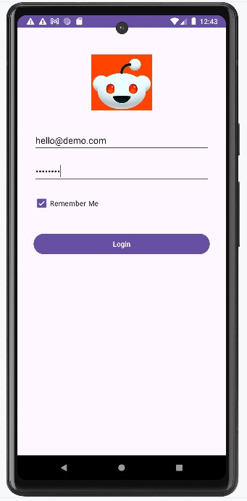

Home page Successful Logout 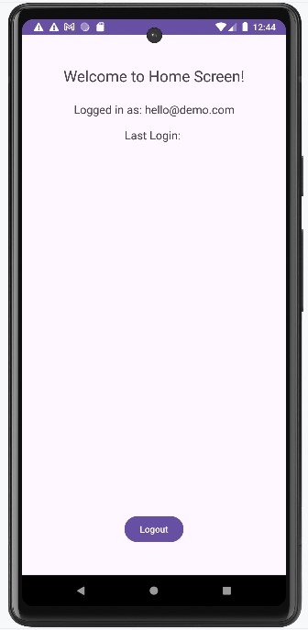 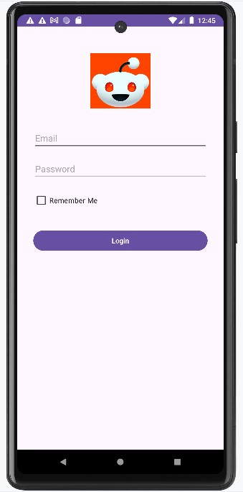

**Assignment 9**

Aim: Create an Android application that demonstrates an alert, where the decision to save the user's credentials in Shared Preferences is determined by the alert action button selected by the user.

CODE:

# MainActivity.java

package com.example.sharedpref;

import android.os.Bundle; import androidx.activity.EdgeToEdge;

import androidx.appcompat.app.AppCompatActivity;

import androidx.core.graphics.Insets; import androidx.core.view.ViewCompat; import androidx.core.view.WindowInsetsCompat;

import android.content.Intent; import android.content.SharedPreferences; import android.os.Bundle;

import android.os.Handler;

public class MainActivity extends AppCompatActivity {

private static final int SPLASH_DELAY = 3000; // 3 seconds

@Override

protected void onCreate(Bundle savedInstanceState) { super.onCreate(savedInstanceState);

setContentView(R.layout.activity_main);

new Handler().postDelayed(new Runnable() {

@Override public void run() {

SharedPreferences sharedPreferences = getSharedPreferences("LoginPrefs",

MODE_PRIVATE);

String username = sharedPreferences.getString("username", null);

String password = sharedPreferences.getString("password", null);

Intent intent;

if (username != null && password != null) {

intent = new Intent(MainActivity.this, Home.class);

} else {

intent = new Intent(MainActivity.this, Login.class);

}

startActivity(intent);

finish();

}

}, SPLASH_DELAY);

}

}

*Login.java* package com.example.sharedpref;

import android.content.DialogInterface; import android.content.Intent; import android.content.SharedPreferences; import android.os.Bundle; import android.view.View; import android.widget.Button; import android.widget.CheckBox; import android.widget.EditText; import android.widget.Toast;

import androidx.appcompat.app.AlertDialog; import androidx.appcompat.app.AppCompatActivity;

public class Login extends AppCompatActivity {

private EditText edtEmail, edtPassword;

private CheckBox chkRememberMe;

private Button btnLogin,btnalert;

private static final String VALID_EMAIL = "hello@demo.com"; private static final String VALID_PASSWORD = "noob@123";

@Override protected void onCreate(Bundle savedInstanceState) { super.onCreate(savedInstanceState); setContentView(R.layout.activity_login);

edtEmail = findViewById(R.id.edtEmail); edtPassword = findViewById(R.id.edtPassword); chkRememberMe = findViewById(R.id.chkRememberMe);

btnLogin = findViewById(R.id.btnLogin); btnalert = findViewById(R.id.btnalert);

SharedPreferences sharedPreferences = getSharedPreferences("LoginPrefs",

MODE_PRIVATE);

String savedEmail = sharedPreferences.getString("email", null);

String savedPassword = sharedPreferences.getString("password", null);

if (savedEmail != null && savedPassword != null) { startActivity(new Intent(Login.this, Home.class));

finish();

}

btnLogin.setOnClickListener(new View.OnClickListener() {

@Override public void onClick(View v) {

String email = edtEmail.getText().toString();

String password = edtPassword.getText().toString();

if (email.equals(VALID_EMAIL) && password.equals(VALID_PASSWORD)) {

if (chkRememberMe.isChecked()) {

SharedPreferences.Editor editor = sharedPreferences.edit(); editor.putString("email", email); editor.putString("password", password);

editor.apply();

}

startActivity(new Intent(Login.this, Home.class));

finish();

} else {

Toast.makeText(Login.this, "Invalid credentials!", Toast.LENGTH_SHORT).show();

}

}

});

btnalert.setOnClickListener(new View.OnClickListener() {

@Override public void onClick(View v) {

AlertDialog.Builder alertobj=new AlertDialog.Builder(Login.this); alertobj.setTitle("New Alert"); alertobj.setMessage("Do you want to save the user details?"); alertobj.setIcon(R.drawable.img);

// alertobj.show();

alertobj.setPositiveButton("YES", new DialogInterface.OnClickListener() {

@Override public void onClick(DialogInterface dialog, int which) {

Toast.makeText(getApplicationContext(),"User details has been saved.",Toast.LENGTH_LONG).show();

}

});

alertobj.setNegativeButton("NO", new DialogInterface.OnClickListener() {

@Override public void onClick(DialogInterface dialog, int which) {

Toast.makeText(getApplicationContext(),"User details has not been saved.",Toast.LENGTH_LONG).show();

}

});

alertobj.show();

}

});

}

}

# Home.java

package com.example.sharedpref;

import android.os.Bundle; import android.content.Intent; import android.content.SharedPreferences; import android.os.Bundle;

import android.view.View; import android.widget.Button; import android.widget.TextView;

import androidx.appcompat.app.AppCompatActivity;

public class Home extends AppCompatActivity {

private TextView tvWelcome, tvEmail; private Button btnLogout;

@Override

protected void onCreate(Bundle savedInstanceState) { super.onCreate(savedInstanceState);

setContentView(R.layout.activity_home);

tvWelcome = findViewById(R.id.tvWelcome); tvEmail = findViewById(R.id.tvEmail);

btnLogout = findViewById(R.id.btnLogout);

SharedPreferences sharedPreferences = getSharedPreferences("LoginPrefs",

MODE_PRIVATE);

String email = sharedPreferences.getString("email", "N/A");

tvWelcome.setText("Welcome to Home Screen!"); tvEmail.setText("Logged in as: " + email);

btnLogout.setOnClickListener(new View.OnClickListener() {

@Override

public void onClick(View v) {

// Clear all login information

SharedPreferences.Editor editor = sharedPreferences.edit(); editor.clear();

editor.apply();

// Navigate back to Login screen

Intent intent = new Intent(Home.this, Login.class); intent.setFlags(Intent.FLAG_ACTIVITY_NEW_TASK | Intent.FLAG_ACTIVITY_CLEAR_TASK);

startActivity(intent); finish();

}

});

}

}

OUTPUT:

On Clicking Yes

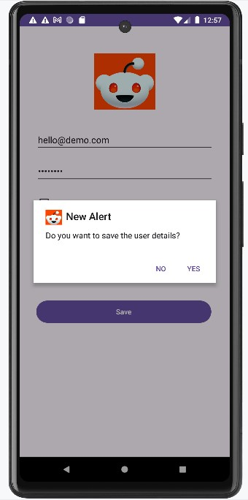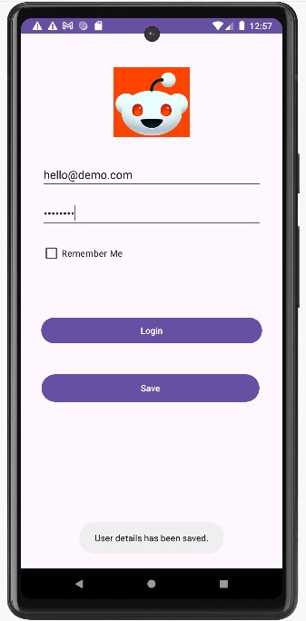

On Clicking No:

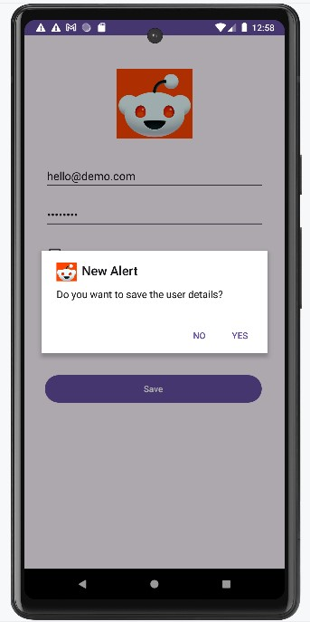 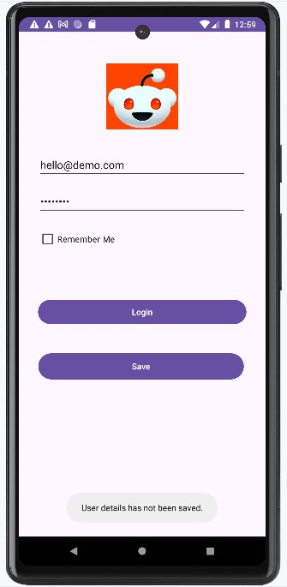

**Assignment 10**

Aim: Create an Android application that demonstrates notifications, where tapping on a notification in the notification bar directs the user to the appropriate activity.

CODE:

*MainActivity.java* package com.example.alert;

import androidx.appcompat.app.AlertDialog; import androidx.appcompat.app.AppCompatActivity; import androidx.core.app.NotificationCompat; import android.app.NotificationChannel; import android.app.NotificationManager; import android.app.PendingIntent; import android.content.Context; import android.content.DialogInterface; import android.content.Intent; import android.net.Uri; import android.os.Build; import android.os.Bundle; import android.view.View; import android.widget.Toast;

import java.net.URL; import java.nio.channels.Channel;

public class MainActivity extends AppCompatActivity {

NotificationChannel channel;

int notification_id = 0;

@Override protected void onCreate(Bundle savedInstanceState) { super.onCreate(savedInstanceState); setContentView(R.layout.activity_main);

Button btnnotification; btnnotification=findViewById(R.id.btnnotification);

btnnotification.setOnClickListener(new View.OnClickListener() {

@Override public void onClick(View v) {

NotificationManager nm=(NotificationManager) getSystemService(Context.NOTIFICATION_SERVICE);

if(Build.VERSION.SDK_INT>= Build.VERSION_CODES.O)

{

channel=new

NotificationChannel("mychannel","ABC",NotificationManager.IMPORTANCE_HIGH);

nm.createNotificationChannel(channel);

}

NotificationCompat.Builder builder=new

NotificationCompat.Builder(MainActivity.this,"mychannel")

.setSmallIcon(R.drawable.img)

.setContentTitle("New Message")

.setAutoCancel(true)

.setContentText("You have received a New Message");

Intent notificationintent=new Intent(getApplicationContext(), notification.class);

startActivity(notificationintent);

PendingIntent

content=PendingIntent.getActivity(getApplicationContext(),0,notificationintent,PendingIntent.F LAG_IMMUTABLE);

builder.setContentIntent(content); nm.notify(0,builder.build());

}

});

}

}

*notification.java* package com.example.alert;

import androidx.appcompat.app.AppCompatActivity; import android.os.Bundle;

public class notification extends AppCompatActivity {

@Override protected void onCreate(Bundle savedInstanceState) { super.onCreate(savedInstanceState); setContentView(R.layout.activity_notification);

}

}

OUTPUT:

Button pressed Notification clicked Activity

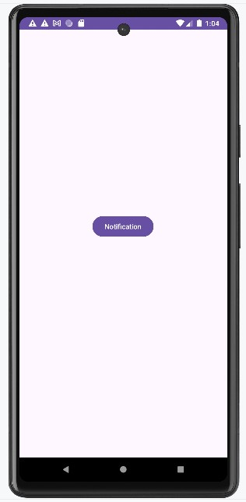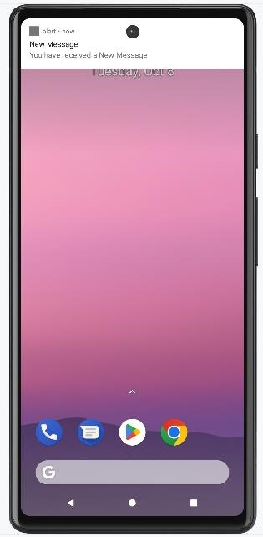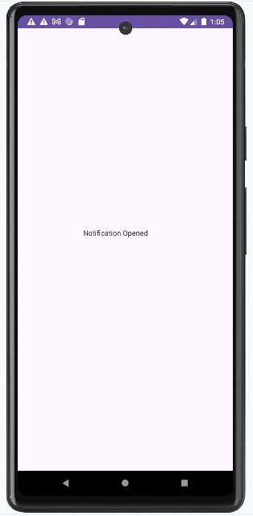

**Assignment 11**

Aim: Write an android application for Internal and external file storage, Input the content in both single and Multiple line edit text , read and display the entered content in the same page.

CODE:

*MainActivity.java* package com.example.storage;

import androidx.appcompat.app.AppCompatActivity; import android.os.Bundle; import android.os.Environment; import android.view.View; import android.widget.Button; import android.widget.EditText; import android.widget.TextView; import android.widget.Toast; import java.io.BufferedReader; import java.io.DataInputStream;

import java.io.File; import java.io.FileInputStream; import java.io.FileNotFoundException; import java.io.FileOutputStream; import java.io.IOException; import java.io.InputStream; import java.io.InputStreamReader; import java.io.OutputStreamWriter; public class MainActivity extends AppCompatActivity {

File myFile; @Override protected void onCreate(Bundle savedInstanceState) { super.onCreate(savedInstanceState); setContentView(R.layout.activity_main);

EditText edtdata,edtmult;

TextView txtmessage;

Button btnread,btnwrite,btneread,btnewrite;

edtdata = findViewById(R.id.edtdata); edtmult = findViewById(R.id.edtmult); txtmessage = findViewById(R.id.txtmessage); btnread = findViewById(R.id.btnread); btnwrite = findViewById(R.id.btnwrite); btneread = findViewById(R.id.btneread); btnewrite = findViewById(R.id.btnewrite);

String extstoragestate= Environment.getExternalStorageState(); if(! Environment.MEDIA_MOUNTED_READ_ONLY.equals(extstoragestate)

& Environment.MEDIA_MOUNTED.equals(extstoragestate))

{

myFile=new File(getExternalFilesDir("myDir"),"sample.txt");

}

btnwrite.setOnClickListener(new View.OnClickListener() {

@Override public void onClick(View v) {

try {

String message=edtmult.getText().toString(); FileOutputStream fosboj =null; fosboj= openFileOutput("messagefile",MODE_PRIVATE); OutputStreamWriter writerobj = new OutputStreamWriter(fosboj);

writerobj.write(message); writerobj.flush(); writerobj.close();

}

catch (Exception e) {

e.printStackTrace();

}

edtdata.setText(" ");

Toast.makeText(getApplicationContext(),"message internally saved",Toast.LENGTH_LONG).show();

}

});

btnread.setOnClickListener(new View.OnClickListener() {

@Override public void onClick(View v) { String msg= " ";

try {

FileInputStream fisobj = openFileInput("messagefile");

InputStreamReader readerobj=new InputStreamReader(fisobj);

char[] buffer= new char[250]; int charread=0;

while ((charread = readerobj.read(buffer))>0)

{

String data = String.copyValueOf(buffer,0,charread);

msg += data;

}

readerobj.close();

Toast.makeText(getApplicationContext(),"message internally reading",Toast.LENGTH_LONG).show();

}

catch (Exception e) {

e.printStackTrace();

}

txtmessage.setText(msg);

}

});

btnewrite.setOnClickListener(new View.OnClickListener() {

@Override public void onClick(View v) { FileOutputStream fos=null;

try {

fos=new FileOutputStream(myFile);

fos.write(edtmult.getText().toString().getBytes());

fos.close();

}

catch (Exception e) {

e.printStackTrace();

}

edtdata.setText(" ");

Toast.makeText(getApplicationContext(),"message externally saved",Toast.LENGTH_LONG).show();

System.out.println("The path is: "+getExternalFilesDir("myDir"));

//:/storage/emulated/0/Android/data/com.example.storagedemo/files/myDir

}

});

btneread.setOnClickListener(new View.OnClickListener() {

@Override public void onClick(View v) { String mydata=" "; FileInputStream fis=null;

try {

fis=new FileInputStream(myFile);

DataInputStream dis=new DataInputStream(fis);

BufferedReader br=new BufferedReader(new InputStreamReader(dis));

String line;

while ((line=br.readLine())!=null) mydata +="\n" +line;

dis.close();

txtmessage.setText(mydata);

}

catch (Exception e)

{

e.printStackTrace();

}

Toast.*makeText*(getApplicationContext(),"message externally reading",Toast.*LENGTH_LONG*).show();

}

});

}

}

OUTPUT:

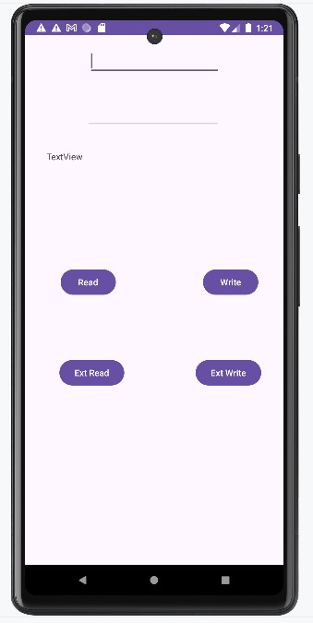

Single Line Internal Storage

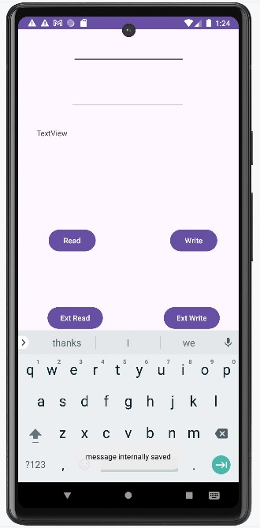 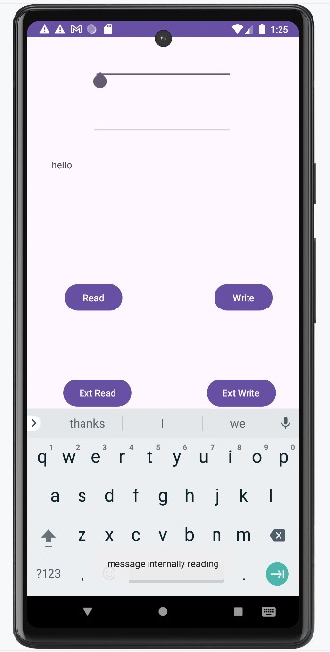

Multiple Line Internal Storage

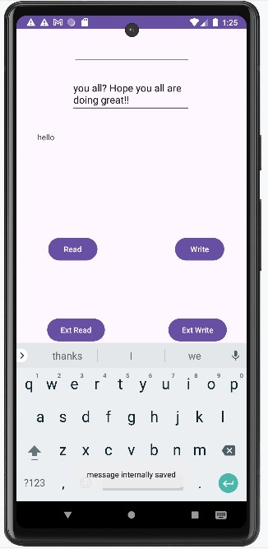 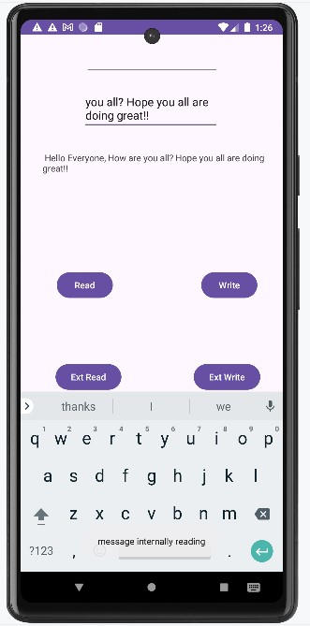

Single Line External Storage

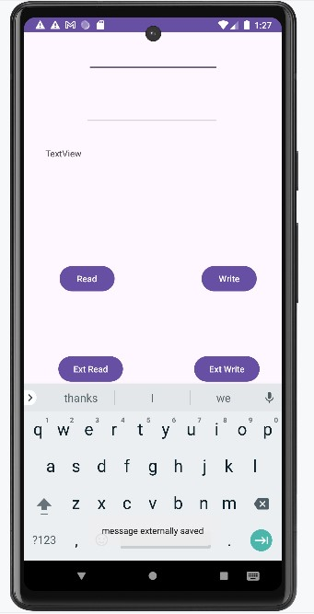 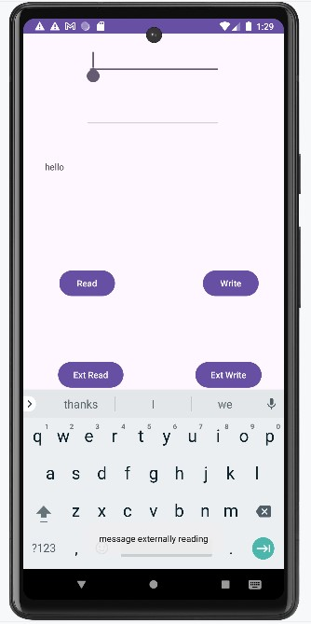

Multiple Line External Storage

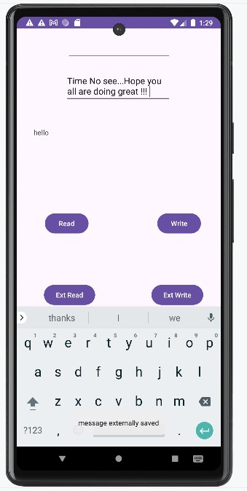 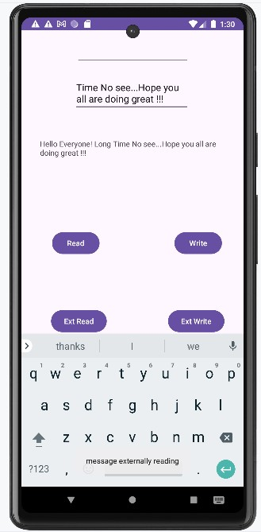

*Device Explorer:*

For internal storage

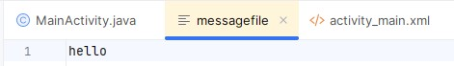

For external storage

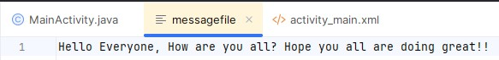

**Assignment 12**

Aim: Create an Android application that enables users to play audio files with adjustable volume and a video player with a progress bar feature.

CODE:

*MainActivity.java* package com.example.avplayer;

import androidx.appcompat.app.AppCompatActivity; import android.content.Context; import android.media.AudioManager; import android.media.MediaPlayer; import android.net.Uri; import android.os.Bundle; import android.os.Handler; import android.view.View; import android.widget.Button; import android.widget.ProgressBar; import android.widget.SeekBar; import android.widget.Toast; import android.widget.VideoView;

public class MainActivity extends AppCompatActivity { MediaPlayer mp; private ProgressBar videoProgressBar; private VideoView vv; private Handler handler = new Handler(); @Override protected void onCreate(Bundle savedInstanceState) { super.onCreate(savedInstanceState); setContentView(R.layout.activity_main);

Button btnplay,btnpause,btnstop,btnvplay,btnvpause,btnvstop;

SeekBar s;

btnplay = findViewById(R.id.btnplay); btnpause = findViewById(R.id.btnpause); btnstop = findViewById(R.id.btnstop); s = findViewById(R.id.s);

btnvplay = findViewById(R.id.btnvplay); btnvpause = findViewById(R.id.btnvpause); btnvstop = findViewById(R.id.btnvstop); vv = findViewById(R.id.vv); videoProgressBar = findViewById(R.id.videoprogressbar);

String apath="android.resource://" + getPackageName() + "/raw/testt"; Uri uripath = Uri.parse(apath); vv.setVideoURI(uripath); vv.setVideoPath(apath);

mp = MediaPlayer.create(this, R.raw.test);

AudioManager aud = (AudioManager) getSystemService(Context.AUDIO_SERVICE); int max = aud.getStreamMaxVolume(AudioManager.STREAM_MUSIC); int prog = aud.getStreamVolume(AudioManager.STREAM_MUSIC);

s.setMax(max);

s.setProgress(prog);

btnplay.setOnClickListener(new View.OnClickListener() {

@Override public void onClick(View v) {

Toast.makeText(getApplicationContext(), "music playing", Toast.LENGTH_LONG).show();

mp.start();

}

});

btnpause.setOnClickListener(new View.OnClickListener() {

@Override public void onClick(View v) {

Toast.makeText(getApplicationContext(), "music paused", Toast.LENGTH_LONG).show();

mp.pause();

}

});

btnstop.setOnClickListener(new View.OnClickListener() {

@Override public void onClick(View v) { Toast.makeText(getApplicationContext(), "music stopped", Toast.LENGTH_LONG).show();

mp.pause(); mp.seekTo(0);

}

});

btnvplay.setOnClickListener(new View.OnClickListener() {

@Override public void onClick(View v) {

Toast.makeText(getApplicationContext(), "video playing", Toast.LENGTH_LONG).show();

vv.start();

updateVideoProgressBar();

}

});

btnvpause.setOnClickListener(new View.OnClickListener() {

@Override public void onClick(View v) {

Toast.makeText(getApplicationContext(), "video paused", Toast.LENGTH_LONG).show();

vv.pause();

handler.removeCallbacks(updateVideoProgressBarRunnable);

}

});

btnvstop.setOnClickListener(new View.OnClickListener() {

@Override public void onClick(View v) {

Toast.makeText(getApplicationContext(), "video stopped", Toast.LENGTH_LONG).show();

vv.pause(); vv.seekTo(0);

videoProgressBar.setProgress(0); handler.removeCallbacks(updateVideoProgressBarRunnable);

}

});

vv.setOnPreparedListener(new MediaPlayer.OnPreparedListener() {

@Override public void onPrepared(MediaPlayer mp) { videoProgressBar.setMax(vv.getDuration());

}

});

}

private void updateVideoProgressBar() { handler.postDelayed(updateVideoProgressBarRunnable, 200); // Update every 200 ms

}

private Runnable updateVideoProgressBarRunnable = new Runnable() {

@Override public void run() { if (vv != null && vv.isPlaying()) { int currentPosition = vv.getCurrentPosition(); int duration = vv.getDuration();

// Increase the increment rate for faster filling

int progress = (int) ((float) currentPosition / duration * 400); // Increase multiplier for faster progress if (progress > 100) progress = 100; // Cap the progress at 100 videoProgressBar.setProgress(progress); handler.postDelayed(this, 200); // Update every 200 ms

}

}

};

}

OUTPUT:

For Music Player

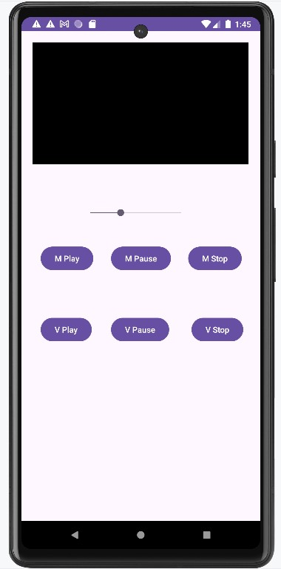 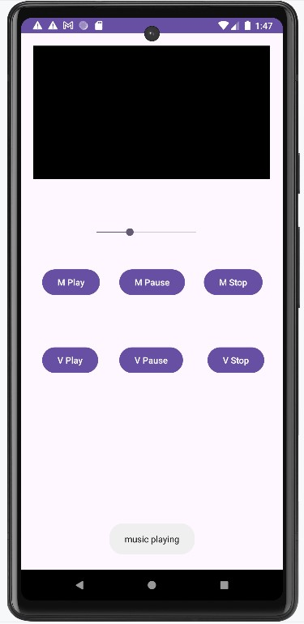

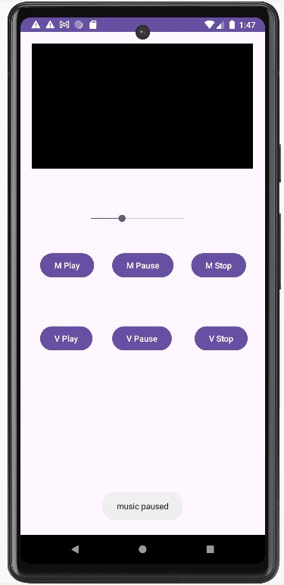 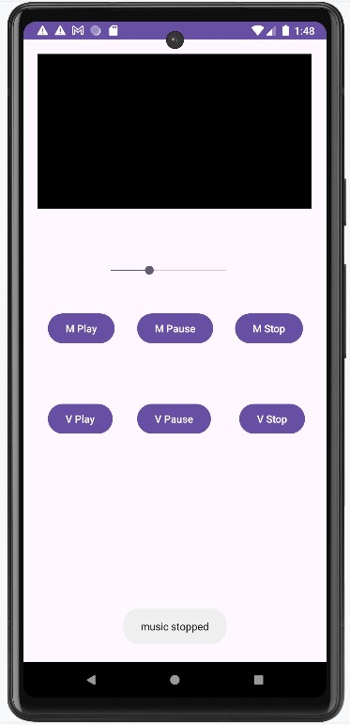

For Video Player

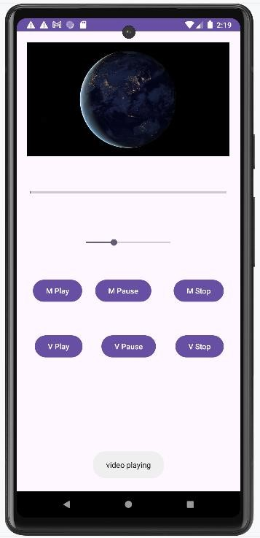 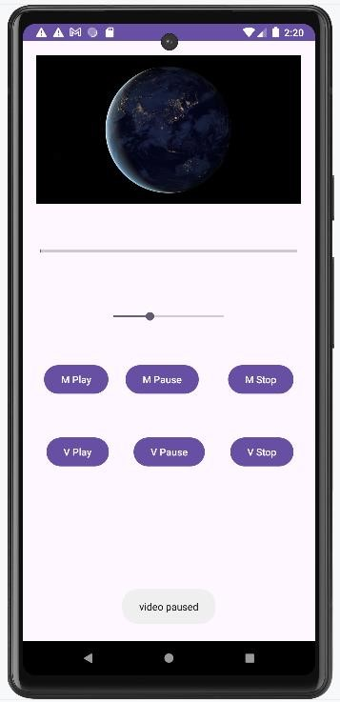

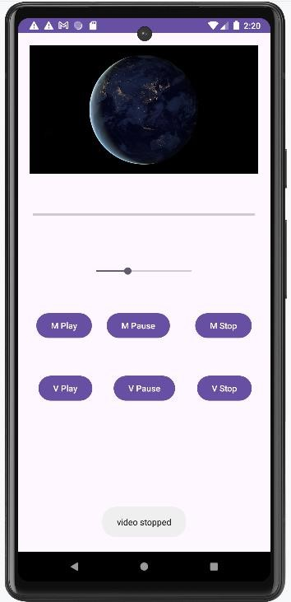

**Assignment 13**

Aim: Prepare Student Database with table Student with any 5 relevant fields, perform the following operations on it.

Create Table

1. Insert new records
2. View all the Stored Records
3. Search record based on Roll Number
4. Delete Record based on Name
5. Update record based on roll number

CODE:

*MainActivity.java* package com.example.sqlite;

import android.database.Cursor; import android.os.Bundle; import android.view.View; import android.widget.Button; import android.widget.EditText; import android.widget.Toast;

import androidx.activity.EdgeToEdge; import androidx.appcompat.app.AlertDialog; import androidx.appcompat.app.AppCompatActivity; import androidx.core.graphics.Insets; import androidx.core.view.ViewCompat; import androidx.core.view.WindowInsetsCompat; public class MainActivity extends AppCompatActivity {

EditText ed_rollNo, ed_name, ed_department, ed_age, ed_passFail;

Button btn_save, btn_read, btn_search, btn_del, btn_upd;

DBhelper dbHelper;

@Override protected void onCreate(Bundle savedInstanceState) { super.onCreate(savedInstanceState); setContentView(R.layout.activity_main);

ed_name = findViewById(R.id.ed_name); ed_rollNo = findViewById(R.id.ed_rollNo); ed_department = findViewById(R.id.ed_department); ed_age = findViewById(R.id.ed_age); ed_passFail = findViewById(R.id.ed_passFail); btn_save = findViewById(R.id.btn_save); btn_read = findViewById(R.id.btn_read); btn_search = findViewById(R.id.btn_search); btn_del = findViewById(R.id.btn_del); btn_upd = findViewById(R.id.btn_upd);

dbHelper = new DBhelper(this);

// Insert Record btn_save.setOnClickListener(new View.OnClickListener() {

@Override

public void onClick(View v) {

try {

String name = ed_name.getText().toString(); int rollNo = Integer.parseInt(ed_rollNo.getText().toString()); String department = ed_department.getText().toString();

int age = Integer.parseInt(ed_age.getText().toString());

String passFail = ed_passFail.getText().toString();

boolean isSaved = dbHelper.saveData(rollNo, name, department, age, passFail);

if (isSaved) {

Toast.makeText(getApplicationContext(), "Record Inserted", Toast.LENGTH_LONG).show();

} else {

Toast.makeText(getApplicationContext(), "Failed to Insert Record", Toast.LENGTH_LONG).show();

}

} catch (NumberFormatException e) {

Toast.makeText(getApplicationContext(), "Please enter valid data", Toast.LENGTH_LONG).show();

}

}

});

// Read Record btn_read.setOnClickListener(new View.OnClickListener() {

@Override

public void onClick(View v) {

StringBuilder buffer = new StringBuilder(); Cursor cursor = dbHelper.showData();

if (cursor.getCount() == 0) {

Toast.makeText(getApplicationContext(), "No Records", Toast.LENGTH_SHORT).show();

} else {

while (cursor.moveToNext()) { buffer.append("Name: ").append(cursor.getString(1)).append("\n"); buffer.append("Roll No: ").append(cursor.getString(2)).append("\n"); buffer.append("Department: ").append(cursor.getString(3)).append("\n"); buffer.append("Age: ").append(cursor.getString(4)).append("\n"); buffer.append("Pass/Fail: ").append(cursor.getString(5)).append("\n\n");

}

showMessage("Data", buffer.toString());

}

}

});

// Search Record btn_search.setOnClickListener(new View.OnClickListener() {

@Override

public void onClick(View v) {

StringBuilder buffer = new StringBuilder(); int rollNo = Integer.parseInt(ed_rollNo.getText().toString()); Cursor cursor = dbHelper.search(rollNo); if (cursor.getCount() == 0) {

Toast.makeText(getApplicationContext(), "No Records Found",

Toast.LENGTH_SHORT).show();

} else {

while (cursor.moveToNext()) { buffer.append("Name: ").append(cursor.getString(1)).append("\n"); buffer.append("Roll No: ").append(cursor.getString(2)).append("\n"); buffer.append("Department: ").append(cursor.getString(3)).append("\n"); buffer.append("Age: ").append(cursor.getString(4)).append("\n"); buffer.append("Pass/Fail: ").append(cursor.getString(5)).append("\n\n");

}

showMessage("Data", buffer.toString());

}

}

});

// Delete Record btn_del.setOnClickListener(new View.OnClickListener() {

@Override

public void onClick(View v) { int rollNo = Integer.parseInt(ed_rollNo.getText().toString()); int result = dbHelper.deleteRecord(rollNo);

if (result != 0) {

Toast.makeText(getApplicationContext(), "Record Deleted", Toast.LENGTH_LONG).show();

} else {

Toast.makeText(getApplicationContext(), "Record Deletion Failed", Toast.LENGTH_LONG).show();

}

}

});

// Update Record btn_upd.setOnClickListener(new View.OnClickListener() {

@Override public void onClick(View v) {

String name = ed_name.getText().toString(); int rollNo = Integer.parseInt(ed_rollNo.getText().toString()); String department = ed_department.getText().toString(); int age = Integer.parseInt(ed_age.getText().toString());

String passFail = ed_passFail.getText().toString();

int result = dbHelper.updateRecord(rollNo, name, department, age, passFail);

if (result != 0) {

Toast.makeText(getApplicationContext(), "Record Updated", Toast.LENGTH_LONG).show();

} else {

Toast.makeText(getApplicationContext(), "Failed to Update Record", Toast.LENGTH_LONG).show();

}

}

});

}

public void showMessage(String title, String message) { AlertDialog.Builder builder = new AlertDialog.Builder(this); builder.setCancelable(true); builder.setTitle(title);

builder.setMessage(message);

builder.show();

}

}

*DBhelper.java* package com.example.sqlite;

import android.content.ContentValues; import android.content.Context; import android.database.Cursor; import android.database.sqlite.SQLiteDatabase; import android.database.sqlite.SQLiteOpenHelper; import android.os.Bundle;

import androidx.activity.EdgeToEdge; import androidx.annotation.Nullable; import androidx.appcompat.app.AppCompatActivity; import androidx.core.graphics.Insets; import androidx.core.view.ViewCompat; import androidx.core.view.WindowInsetsCompat;

public class DBhelper extends SQLiteOpenHelper { private static final String DB_NAME = "student.db"; private static final String TABLE_NAME = "student";

public DBhelper(@Nullable Context context) { super(context, DB_NAME, null, 1);

}

@Override public void onCreate(SQLiteDatabase db) {

String query = "CREATE TABLE " + TABLE_NAME +

"(ID INTEGER PRIMARY KEY AUTOINCREMENT, RNO INTEGER, NAME TEXT, DEPARTMENT TEXT, AGE INTEGER, PASS_FAIL TEXT)";

db.execSQL(query);

}

@Override public void onUpgrade(SQLiteDatabase db, int oldVersion, int newVersion) { db.execSQL("DROP TABLE IF EXISTS " + TABLE_NAME);

onCreate(db);

}

public boolean saveData(int rno, String name, String department, int age, String passFail) {

SQLiteDatabase db = getWritableDatabase(); ContentValues cv = new ContentValues(); cv.put("NAME", name); cv.put("RNO", rno);

cv.put("DEPARTMENT", department);

cv.put("AGE", age); cv.put("PASS_FAIL", passFail); long insert = db.insert(TABLE_NAME, null, cv);

return insert != -1;

}

public Cursor showData() {

SQLiteDatabase db = this.getReadableDatabase();

String query = "SELECT * FROM " + TABLE_NAME; return db.rawQuery(query, null);

}

public Cursor search(int rollNo) {

SQLiteDatabase db = this.getReadableDatabase();

String query = "SELECT * FROM " + TABLE_NAME + " WHERE RNO = ?"; return db.rawQuery(query, new String[]{String.valueOf(rollNo)});

}

public int deleteRecord(int rollNo) {

SQLiteDatabase db = this.getWritableDatabase(); return db.delete(TABLE_NAME, "RNO = ?", new String[]{String.valueOf(rollNo)});

}

public int updateRecord(int rollNo, String name, String department, int age, String passFail)

{

SQLiteDatabase db = this.getWritableDatabase(); ContentValues cv = new ContentValues(); cv.put("NAME", name); cv.put("DEPARTMENT", department);

cv.put("AGE", age); cv.put("PASS_FAIL", passFail); return db.update(TABLE_NAME, cv, "RNO = ?", new String[]{String.valueOf(rollNo)});

}

}

OUTPUT:

Create Table Insert New Record

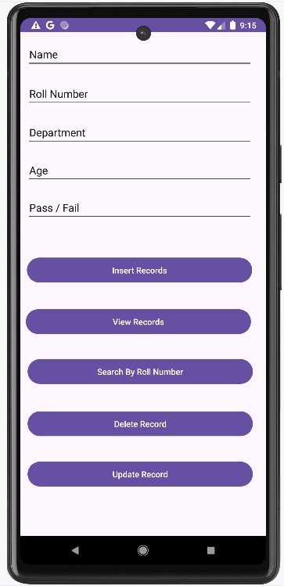 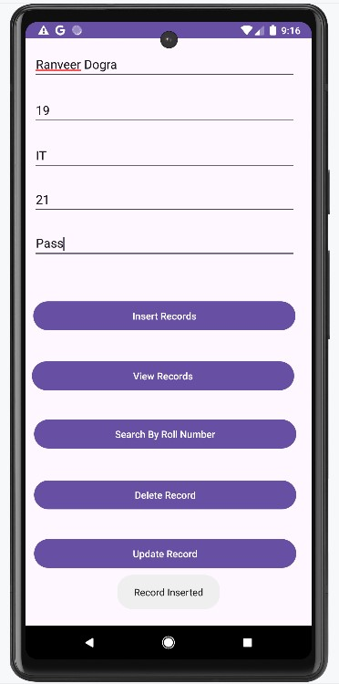

Stored Records Search by Roll Number

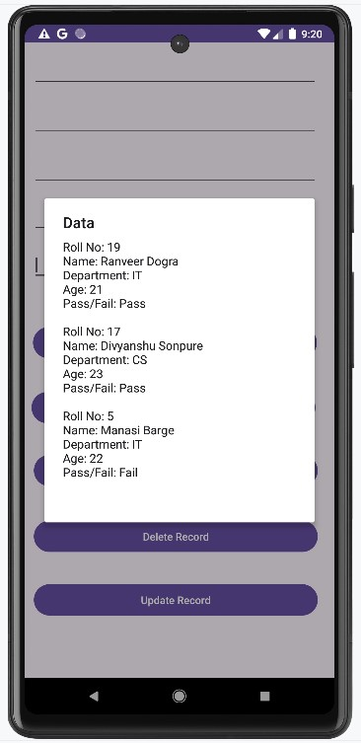 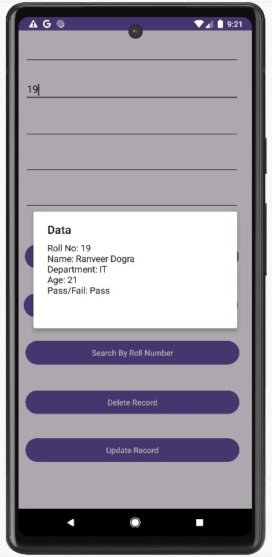

Delete by Name

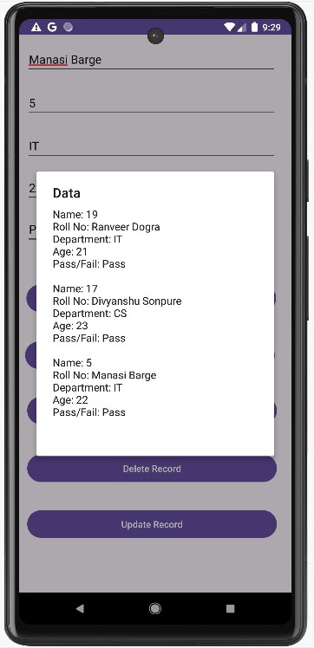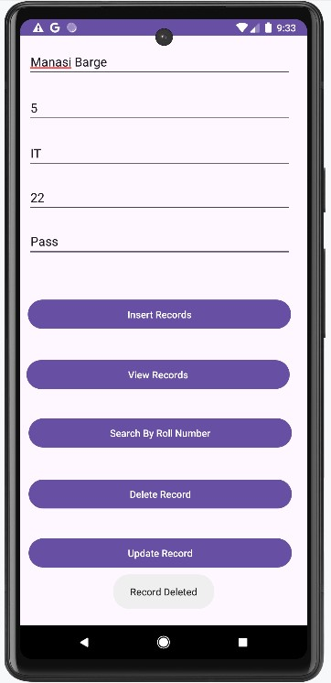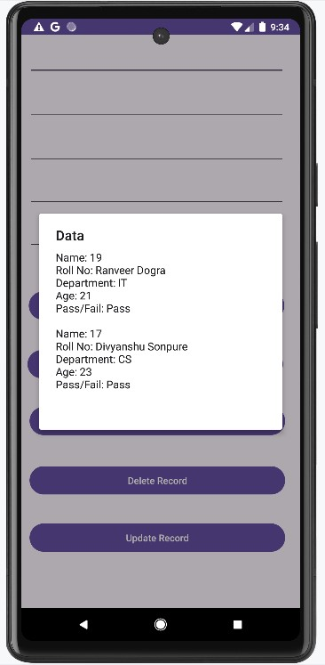

# Update the Record

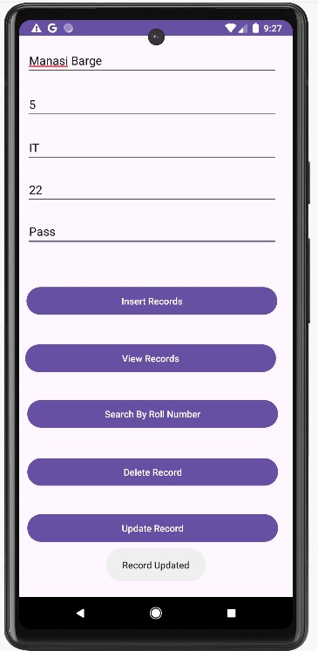

**Assignment 14**

Aim: Create a student record system with the following fields:

Roll number, Name, Age, Email, and Contact number. Use the Volley library to retrieve the records from the server (Use Json Array request)

CODE:

*MainActivity.java* package com.example.volley;

import androidx.appcompat.app.AlertDialog; import androidx.appcompat.app.AppCompatActivity; import android.os.Bundle; import android.view.View; import android.widget.Button; import android.widget.TextView;

import com.android.volley.Request; import com.android.volley.RequestQueue; import com.android.volley.Response; import com.android.volley.VolleyError; import com.android.volley.toolbox.JsonArrayRequest; import com.android.volley.toolbox.StringRequest; import com.android.volley.toolbox.Volley;

import org.json.JSONArray; import org.json.JSONException; import org.json.JSONObject; public class MainActivity extends AppCompatActivity {

TextView tvdata;

Button btnstr, btnfetch;

RequestQueue queue;

@Override protected void onCreate(Bundle savedInstanceState) { super.onCreate(savedInstanceState); setContentView(R.layout.activity_main);

// Initialize Views

tvdata = findViewById(R.id.tvdata); btnstr = findViewById(R.id.btnstr); btnfetch = findViewById(R.id.btnfetch);

// Initialize Volley RequestQueue queue = Volley.newRequestQueue(this);

// JSON URL for fetching student records

String jsonurl = "https://mocki.io/v1/cf2b111b-9ad0-41f7-a1fd-836a994ed66f";

// Fetch JSON data on button click btnfetch.setOnClickListener(new View.OnClickListener() {

@Override public void onClick(View v) {

JsonArrayRequest jsonreq = new JsonArrayRequest(Request.Method.GET, jsonurl, null,

new Response.Listener<JSONArray>() {

@Override

public void onResponse(JSONArray response) { StringBuilder buffer = new StringBuilder();

try {

for (int i = 0; i < response.length(); i++) {

JSONObject student = response.getJSONObject(i);

buffer.append("Roll Number:

").append(student.getInt("rollNumber")).append("\n");

buffer.append("Name:

").append(student.getString("name")).append("\n");

buffer.append("Age: ").append(student.getInt("age")).append("\n");

buffer.append("Email:

").append(student.getString("email")).append("\n");

buffer.append("Contact:

").append(student.getString("contact")).append("\n");

buffer.append("-------------------\n");

}

showMessage("Student Records", buffer.toString()); } catch (JSONException e) {

e.printStackTrace();

showMessage("Error", "Failed to parse student data");

}

}

},

new Response.ErrorListener() {

@Override

public void onErrorResponse(VolleyError error) { tvdata.setText("Failed to fetch student data"); error.printStackTrace();

}

});

queue.add(jsonreq);

}

});

}

private void showMessage(String title, String message) {

AlertDialog.Builder builder = new AlertDialog.Builder(MainActivity.this); builder.setCancelable(true); builder.setTitle(title);

builder.setMessage(message);

builder.show();

}

}

In *AndroidManifest.xml* Add

<uses-permission android:name="android.permission.INTERNET" />

OUTPUT:

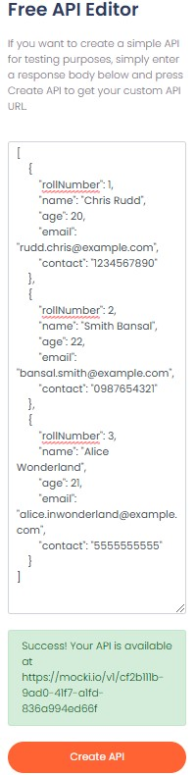Create a JSON Database -

(https://mocki.io/)

[

{

"rollNumber": 1,

"name": "Chris Rudd",

"age": 20,

"email": "rudd.chris@example.com",

"contact": "1234567890"

},

{

"rollNumber": 2,

"name": "Smith Bansal",

"age": 22,

"email": "bansal.smith@example.com",

"contact": "0987654321"

},

{

"rollNumber": 3,

"name": "Alice Wonderland",

"age": 21,

"email":

"alice.inwonderland@example.com",

"contact": "5555555555"

}

]

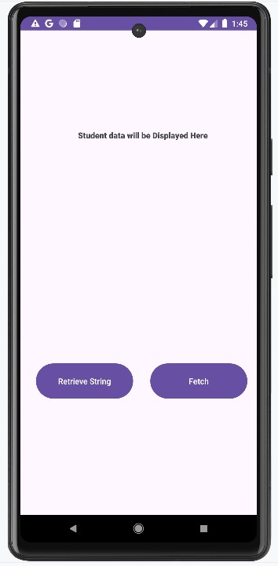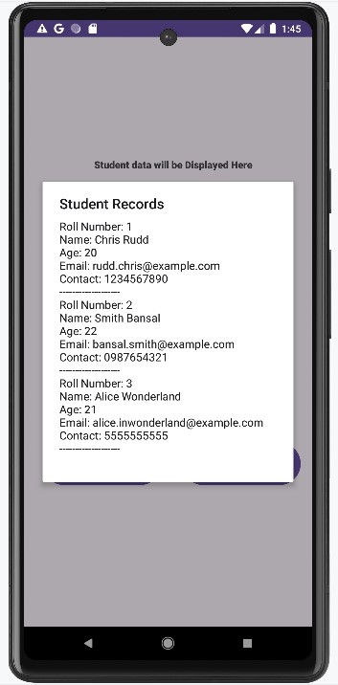

**Assignment 15**

Aim: Create a student record system with the following fields: Roll number, Name, Age, Email, and Contact number. Use the OkHttp library to retrieve the records from the server.

CODE:

*MainActivity.java* package com.example.okhttp;

import android.os.Bundle; import android.os.Handler; import android.os.Looper; import android.util.Log; import android.view.View; import android.widget.Button; import android.widget.TextView; import android.widget.Toast;

import androidx.appcompat.app.AppCompatActivity; import org.json.JSONArray; import org.json.JSONException; import org.json.JSONObject; import java.io.IOException; import okhttp3.Call; import okhttp3.Callback; import okhttp3.OkHttpClient; import okhttp3.Request; import okhttp3.Response;

public class MainActivity extends AppCompatActivity {

private static final String TAG = "MainActivity"; private TextView tvRollNumber, tvName, tvAge, tvEmail, tvContactNumber;

private OkHttpClient client; private Handler mainHandler; private JSONObject studentRecord;

@Override protected void onCreate(Bundle savedInstanceState) { super.onCreate(savedInstanceState); setContentView(R.layout.activity_main);

tvRollNumber = findViewById(R.id.tvRollNumber); tvName = findViewById(R.id.tvName); tvAge = findViewById(R.id.tvAge); tvEmail = findViewById(R.id.tvEmail); tvContactNumber = findViewById(R.id.tvContactNumber);

Button btnFetch = findViewById(R.id.btnFetch);

Button btnRead = findViewById(R.id.btnRead);

client = new OkHttpClient();

mainHandler = new Handler(Looper.getMainLooper());

btnFetch.setOnClickListener(new View.OnClickListener() {

@Override

public void onClick(View v) { fetchStudentRecord();

}

});

btnRead.setOnClickListener(new View.OnClickListener() {

@Override public void onClick(View v) { readStudentRecord();

}

});

}

private void fetchStudentRecord() {

String url = "https://mocki.io/v1/958711e0-f387-4cde-be79-09a3f6bc2c6f";

Request request = new Request.Builder()

.url(url)

.build();

client.newCall(request).enqueue(new Callback() {

@Override public void onFailure(Call call, IOException e) { Log.e(TAG, "Network request failed", e);

mainHandler.post(() -> Toast.makeText(MainActivity.this, "Failed to load data", Toast.LENGTH_SHORT).show());

}

@Override

public void onResponse(Call call, Response response) throws IOException { if (!response.isSuccessful() || response.body() == null) { Log.e(TAG, "Server response error: " + response.code());

mainHandler.post(() -> Toast.makeText(MainActivity.this, "Failed to load data", Toast.LENGTH_SHORT).show());

return;

}

String responseData = response.body().string();

try {

JSONArray jsonArray = new JSONArray(responseData);

if (jsonArray.length() > 0) {

studentRecord = jsonArray.getJSONObject(0); // For only one student record

mainHandler.post(() -> Toast.makeText(MainActivity.this, "Data fetched successfully", Toast.LENGTH_SHORT).show());

} else {

Log.e(TAG, "No records found");

mainHandler.post(() -> Toast.makeText(MainActivity.this, "No records found", Toast.LENGTH_SHORT).show());

}

} catch (JSONException e) {

Log.e(TAG, "Failed to parse JSON", e);

mainHandler.post(() -> Toast.makeText(MainActivity.this, "Failed to parse data", Toast.LENGTH_SHORT).show());

}

}

});

}

private void readStudentRecord() {

if (studentRecord == null) {

Toast.makeText(this, "No data to display", Toast.LENGTH_SHORT).show();

return;

}

try {

String rollNumber = studentRecord.getString("rollNumber"); String name = studentRecord.getString("name"); int age = studentRecord.getInt("age");

String email = studentRecord.getString("email");

String contactNumber = studentRecord.getString("contactNumber");

tvRollNumber.setText("Roll Number: " + rollNumber); tvName.setText("Name: " + name); tvAge.setText("Age: " + age); tvEmail.setText("Email: " + email);

tvContactNumber.setText("Contact Number: " + contactNumber);

} catch (JSONException e) {

Log.e(TAG, "Failed to read JSON", e);

Toast.makeText(this, "Failed to read data", Toast.LENGTH_SHORT).show();

}

}

}

*build.gradle.kts (app)*

Add these dependencies

dependencies { implementation("com.squareup.okhttp3:okhttp:4.9.3"); implementation("com.google.android.material:material:1.3.0"); implementation("androidx.appcompat:appcompat:1.2.0"); implementation("androidx.constraintlayout:constraintlayout:2.0.4");

}

In *AndroidManifest.xml* add

<uses-permission android:name="android.permission.INTERNET" />

OUTPUT:

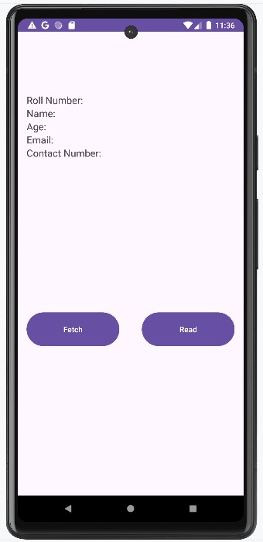 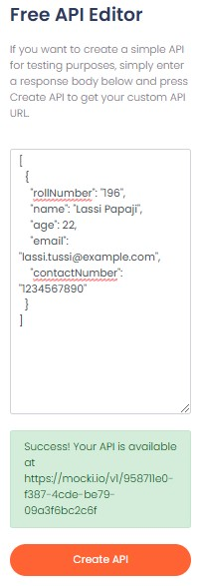

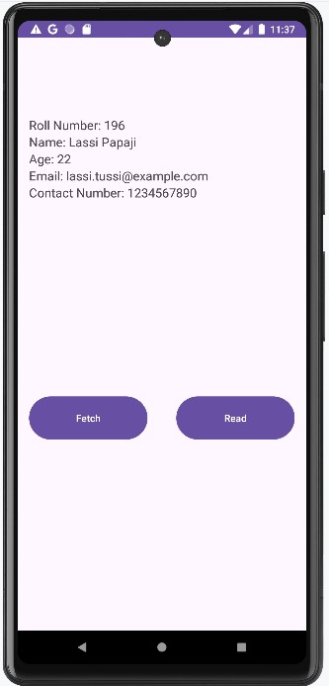Fetch Data Read Data 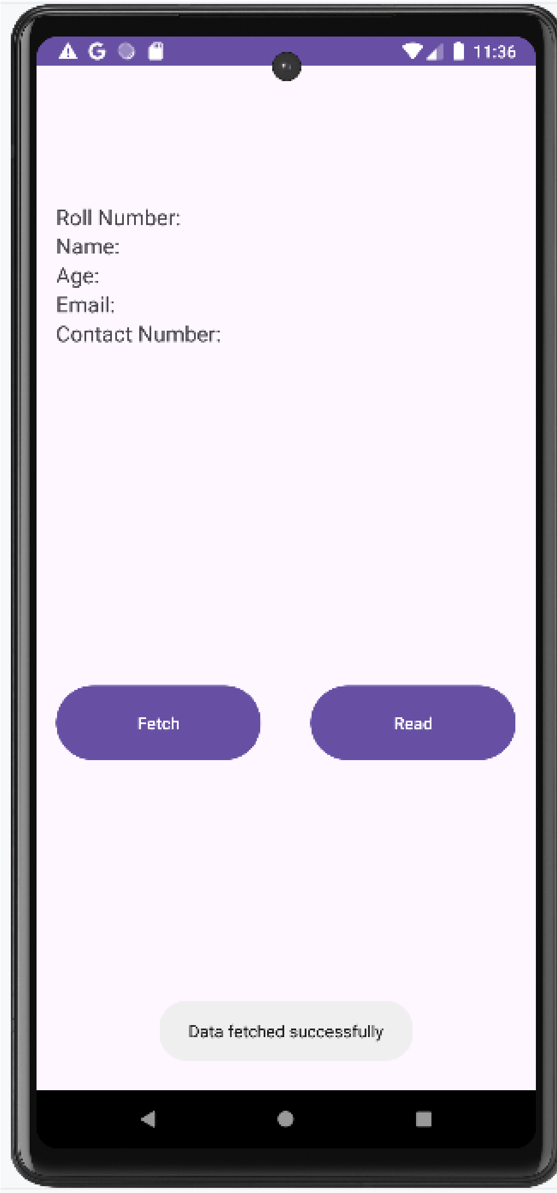

**Assignment 16**

Aim: Create android application to demonstrate REST API integration with the help of Retrofit Library.

CODE:

*MainActivity.java* package com.example.restapi;

import androidx.appcompat.app.AppCompatActivity;

import android.os.Bundle; import android.view.View; import android.widget.Button; import android.widget.TextView;

import java.util.List;

import retrofit2.Call; import retrofit2.Callback; import retrofit2.Response; import retrofit2.Retrofit; import retrofit2.converter.gson.GsonConverterFactory;

public class MainActivity extends AppCompatActivity {

@Override protected void onCreate(Bundle savedInstanceState) { super.onCreate(savedInstanceState); setContentView(R.layout.activity_main);

TextView text;

Button btn;

text = findViewById(R.id.textView); btn = findViewById(R.id.button);

String url = "https://jsonplaceholder.typicode.com/";

btn.setOnClickListener(new View.OnClickListener() {

@Override public void onClick(View v) {

Retrofit retrofit = new Retrofit.Builder()

.baseUrl(url) // url of the json file

.addConverterFactory(GsonConverterFactory.create())

.build();

myapi api = retrofit.create(myapi.class);

Call<List<model>> call = api.getmodels();

call.enqueue(new Callback<List<model>>() {

@Override

public void onResponse(Call<List<model>> call, Response<List<model>> response) { List<model> data = response.body();

for(int i = 0; i< data.size(); i++)

{

text.append("sl no"+data.get(i).getId()+"\n title:"+data.get(i).getTitle() + "\n");

}

}

@Override

public void onFailure(Call<List<model>> call, Throwable t) {

}

});

}

});

}

}

*Model.java* package com.example.restapi;

public class model {

int userId, id;

String title,body;

public model(int userId, int id, String title, String body) { this.userId = userId;

this.id = id; this.title = title;

this.body = body;

}

public int getUserId() {

return userId;

}

public void setUserId(int userId) { this.userId = userId;

}

public int getId() { return id;

}

public void setId(int id) {

this.id = id;

}

public String getTitle() {

return title;

}

public void setTitle(String title) {

this.title = title;

}

public String getBody() { return body;

}

public void setBody(String body) { this.body = body;

}

}

*myapi.java* **(**API between Model.java and MainActivity.java file)

package com.example.resrapi;

import retrofit2.Call;

import retrofit2.http.GET;

import java.util.List;

public interface myapi {

@GET("posts") *//url part posts*

Call <List<model>>getmodels(); *// getmodel is the method returning call of type list array*

}

OUTPUT:

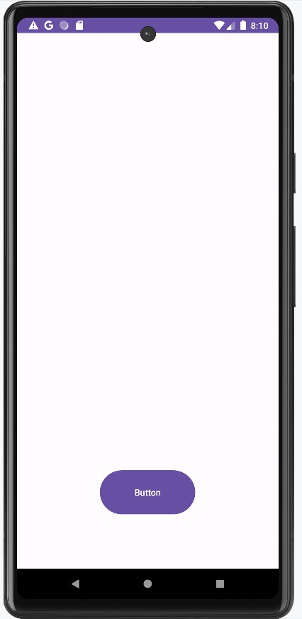 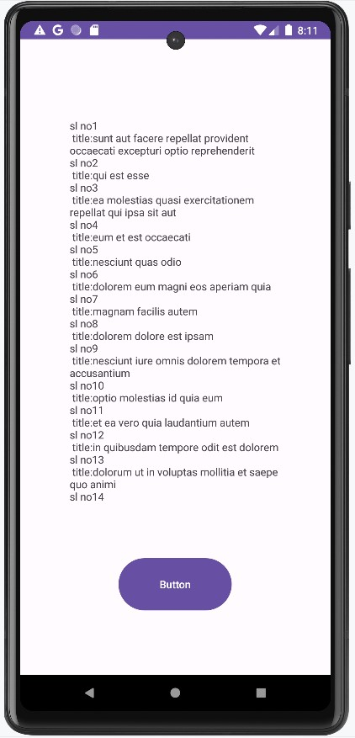

**Assignment 17**

Aim: Write an Android application for Image animation and color effects (Perform the following operations on the image - Translate, scale, Rotate, Zoom in , Zoom out, fade in , Fade Out, Bounce, Invert Color and Grey image)

CODE:

*MainActivity.java* package com.example.animation;

import androidx.appcompat.app.AppCompatActivity;

import android.os.Bundle; import android.view.View; import android.view.animation.Animation; import android.view.animation.AnimationUtils; import android.widget.Button; import android.widget.ImageView;

public class MainActivity extends AppCompatActivity {

@Override protected void onCreate(Bundle savedInstanceState) { super.onCreate(savedInstanceState); setContentView(R.layout.activity_main);

Button btntranslate, btnscale, btnrotate, btnalpha;

ImageView iv;

iv=findViewById(R.id.iv); btntranslate=findViewById(R.id.btntranslate); btnscale=findViewById(R.id.btnscale); btnrotate=findViewById(R.id.btnrotate); btnalpha=findViewById(R.id.btnalpha);

btntranslate.setOnClickListener(new View.OnClickListener() {

@Override public void onClick(View v) {

Animation move = AnimationUtils.loadAnimation(getApplicationContext(), R.anim.move);

iv.startAnimation(move);

}

});

btnscale.setOnClickListener(new View.OnClickListener() {

@Override public void onClick(View v) {

Animation scale = AnimationUtils.loadAnimation(getApplicationContext(), R.anim.scale);

iv.startAnimation(scale);

}

});

btnrotate.setOnClickListener(new View.OnClickListener() {

@Override public void onClick(View v) {

Animation rotate = AnimationUtils.loadAnimation(getApplicationContext(), R.anim.rotate);

iv.startAnimation(rotate);

}

});

btnalpha.setOnClickListener(new View.OnClickListener() {

@Override public void onClick(View v) {

Animation alpha = AnimationUtils.loadAnimation(getApplicationContext(), R.anim.alpha);

iv.startAnimation(alpha);

}

});

}

}

# rotate.xml

<rotate xmlns:android="http://schemas.android.com/apk/res/android" android:duration="1000" android:fromDegrees="0" android:toDegrees="360" android:pivotX="50%" android:pivotY="50%" />

# bounce.xml

<set xmlns:android="http://schemas.android.com/apk/res/android" android:interpolator="@android:anim/bounce_interpolator">

<scale

android:duration="500" android:fromXScale="1" android:fromYScale="1" android:toXScale="1.2" android:toYScale="1.2" android:pivotX="50%" android:pivotY="50%" />

<scale

android:duration="500" android:fromXScale="1.2" android:fromYScale="1.2" android:toXScale="1" android:toYScale="1" android:startOffset="500" android:pivotX="50%" android:pivotY="50%" />

</set>

OUTPUT:

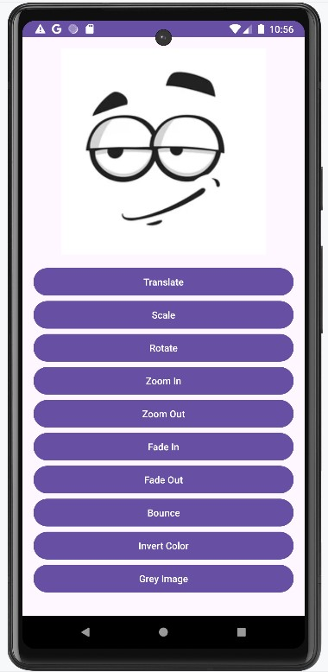

Translate Scale 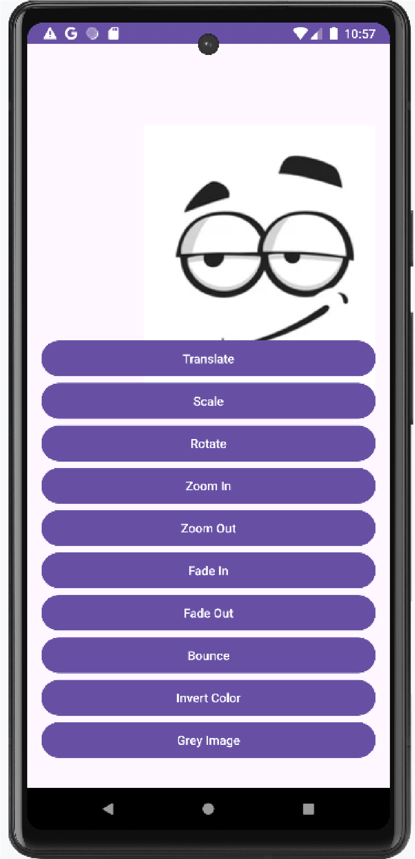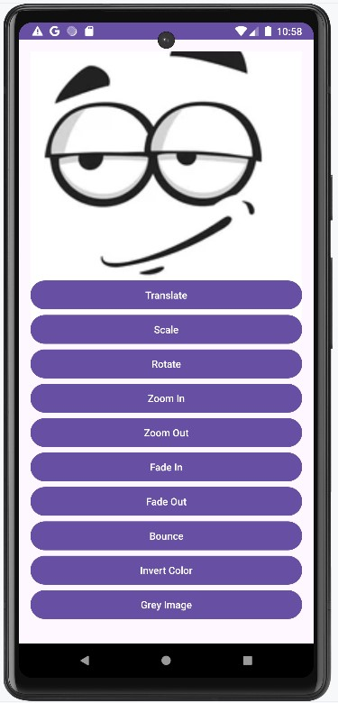

Rotate Zoom in 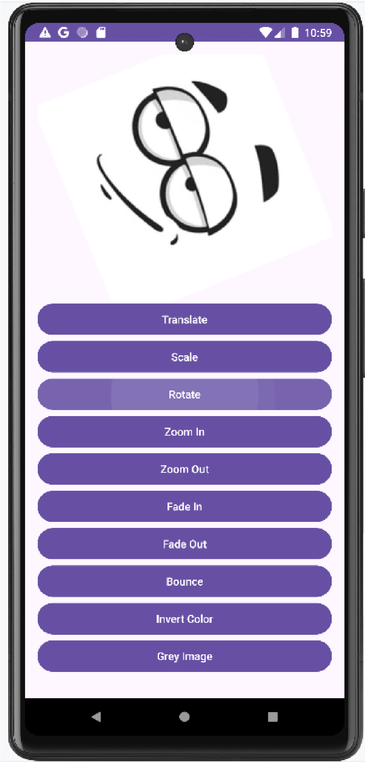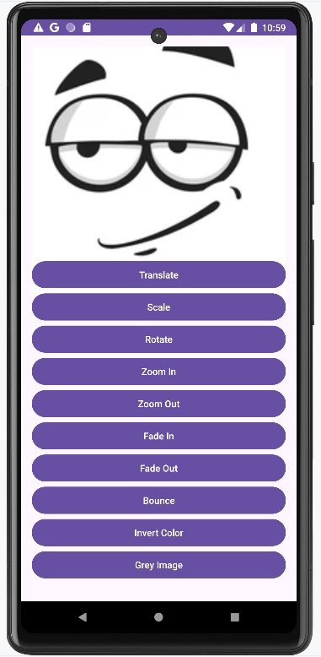

Zoom out Fade in

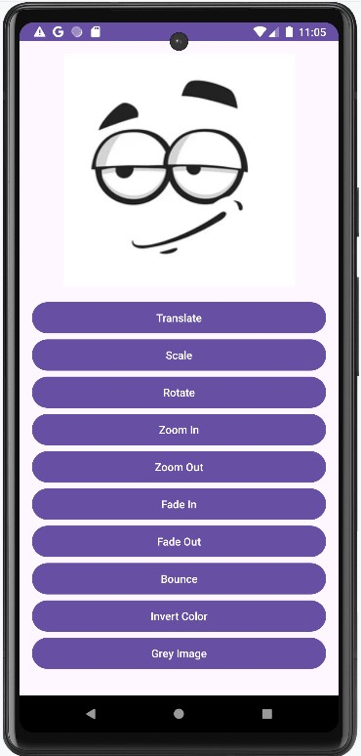 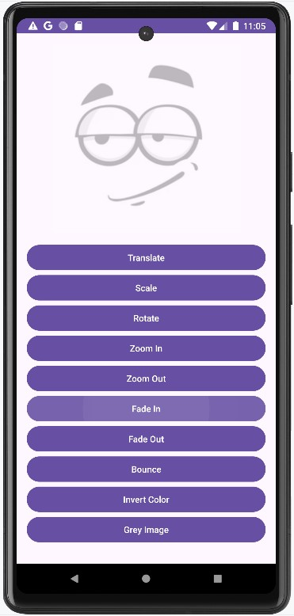

Fade out Bounce 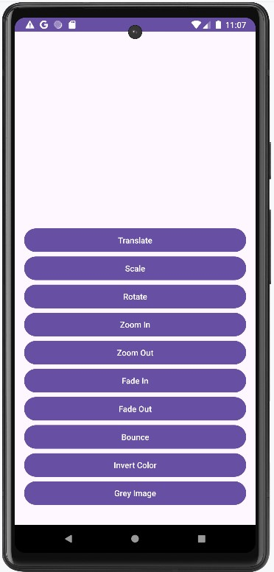 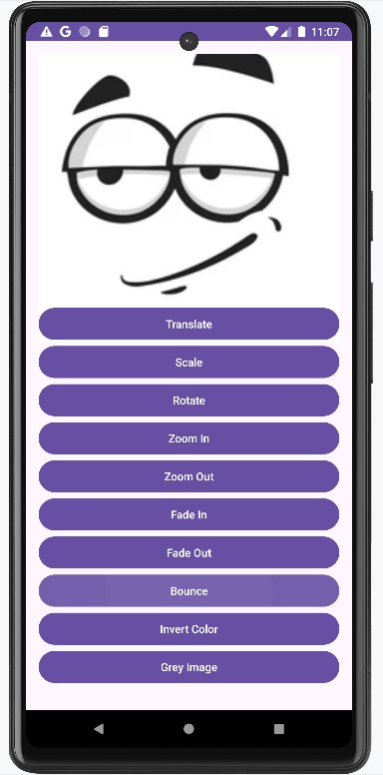

Invert Color Grey image 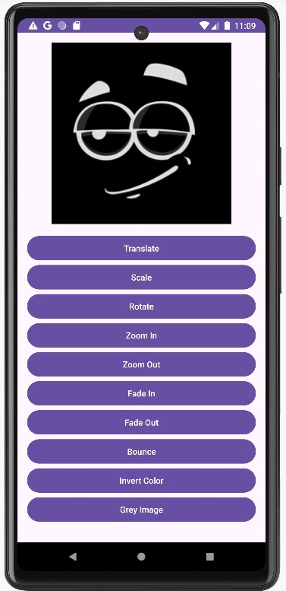 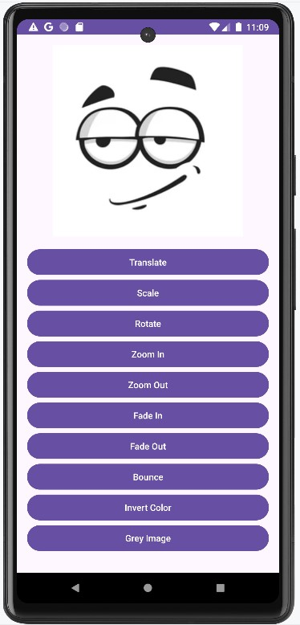

**Assignment 18**

Aim: Implement GPS app in Android.

CODE:

*MainActivity.java* package com.example.gps;

import android.Manifest; import android.content.pm.PackageManager; import android.location.Location; import android.os.Bundle; import android.widget.Button; import android.widget.TextView; import android.widget.Toast;

import androidx.annotation.NonNull; import androidx.appcompat.app.AppCompatActivity; import androidx.core.app.ActivityCompat; import androidx.core.content.ContextCompat;

import com.google.android.gms.location.FusedLocationProviderClient; import com.google.android.gms.location.LocationServices; import com.google.android.gms.tasks.OnSuccessListener;

public class MainActivity extends AppCompatActivity {

private static final int LOCATION_PERMISSION_REQUEST_CODE = 1; private FusedLocationProviderClient fusedLocationClient; private TextView tvLatitude, tvLongitude;

@Override protected void onCreate(Bundle savedInstanceState) { super.onCreate(savedInstanceState); setContentView(R.layout.activity_main);

fusedLocationClient = LocationServices.getFusedLocationProviderClient(this);

tvLatitude = findViewById(R.id.tvLatitude); tvLongitude = findViewById(R.id.tvLongitude);

Button btnGetLocation = findViewById(R.id.btnGetLocation);

btnGetLocation.setOnClickListener(view -> {

if (ContextCompat.checkSelfPermission(this,

Manifest.permission.ACCESS_FINE_LOCATION) != PackageManager.PERMISSION_GRANTED) {

ActivityCompat.requestPermissions(this, new

String[]{Manifest.permission.ACCESS_FINE_LOCATION}, LOCATION_PERMISSION_REQUEST_CODE);

} else {

getLastKnownLocation();

}

});

}

private void getLastKnownLocation() {

if (ContextCompat.checkSelfPermission(this,

Manifest.permission.ACCESS_FINE_LOCATION) == PackageManager.PERMISSION_GRANTED) {

fusedLocationClient.getLastLocation().addOnSuccessListener(this, new OnSuccessListener<Location>() {

@Override public void onSuccess(Location location) {

if (location != null) {

double latitude = location.getLatitude(); double longitude = location.getLongitude(); tvLatitude.setText("Latitude: " + latitude); tvLongitude.setText("Longitude: " + longitude);

} else {

Toast.makeText(MainActivity.this, "Location not found", Toast.LENGTH_SHORT).show();

}

}

});

} else {

Toast.makeText(this, "Permission not granted", Toast.LENGTH_SHORT).show();

}

}

@Override

public void onRequestPermissionsResult(int requestCode, @NonNull String[] permissions,

@NonNull int[] grantResults) { super.onRequestPermissionsResult(requestCode, permissions, grantResults); if (requestCode == LOCATION_PERMISSION_REQUEST_CODE) {

if (grantResults.length > 0 && grantResults[0] ==

PackageManager.PERMISSION_GRANTED) {

getLastKnownLocation();

} else {

Toast.makeText(this, "Permission denied", Toast.LENGTH_SHORT).show();

}

}

}

}

*build.gradle.kts (app)*

Add these dependencies

dependencies **{**

implementation("com.google.android.gms:play-services-location:21.0.1");

**}**

In *AndroidManifest.xml* add

<uses-permission android:name="android.permission.ACCESS_FINE_LOCATION" />

<uses-permission android:name="android.permission.ACCESS_COARSE_LOCATION" />

OUTPUT:

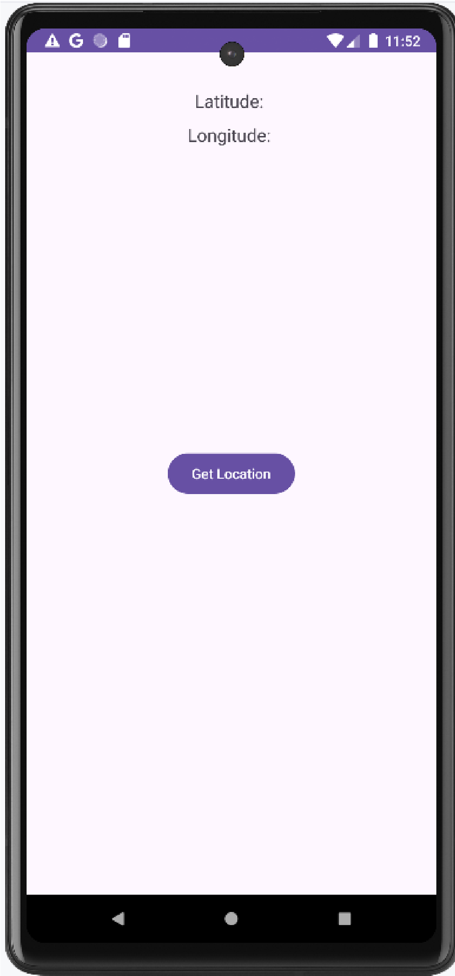 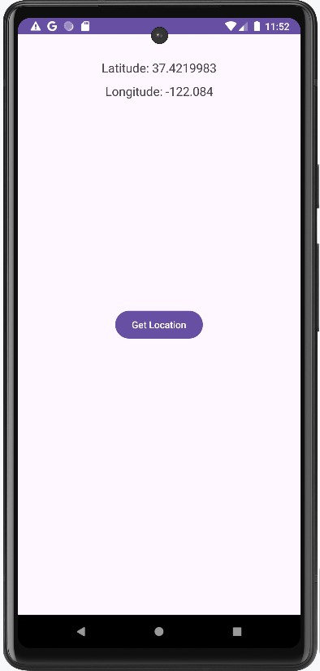

**Assignment 19**

Aim: Implement a Counter Application in Flutter.

CODE:

*main.dart* import 'package:flutter/material.dart';

void main() { runApp(const MyApp());

}

class MyApp extends StatelessWidget { const MyApp({super.key});

// This widget is the root of your application.

@override

Widget build(BuildContext context) { return MaterialApp(

title: 'Flutter Demo',

theme: ThemeData( colorScheme: ColorScheme.fromSeed(seedColor: Colors.deepPurple),

useMaterial3: true,

),

home: const MyHomePage(title: 'Flutter Demo Home Page'),

);

}

}

class MyHomePage extends StatefulWidget { const MyHomePage({super.key, required this.title});

final String title;

@override

State<MyHomePage> createState() => _MyHomePageState();

}

class _MyHomePageState extends State<MyHomePage> {

int _counter = 0;

void _incrementCounter() {

setState(() {

_counter++;

});

}

@override

Widget build(BuildContext context) {

return Scaffold(

appBar: AppBar(

backgroundColor: Theme.of(context).colorScheme.inversePrimary,

title: Text(widget.title),

),

body: Center( child: Column(

mainAxisAlignment: MainAxisAlignment.center,

children: <Widget>[

const Text(

'You have pushed the button this many times:',

),

Text(

'$_counter',

style: Theme.of(context).textTheme.headlineMedium,

),

],

),

),

floatingActionButton: FloatingActionButton( onPressed: _incrementCounter,

tooltip: 'Increment', child: const Icon(Icons.add),

),

); } }

OUTPUT:

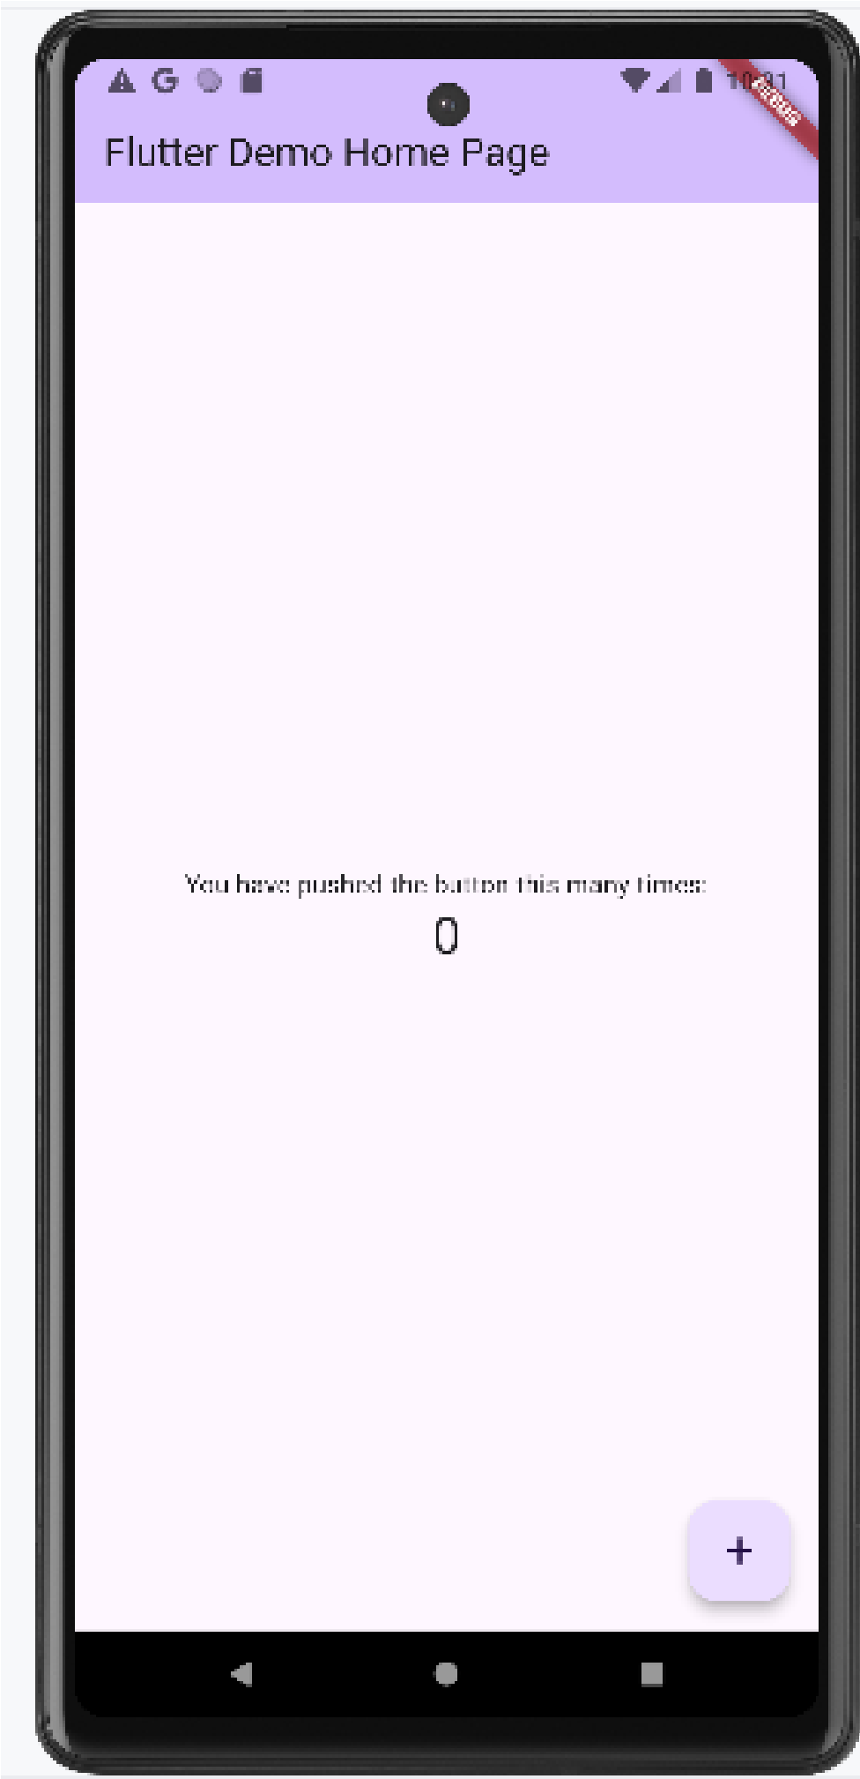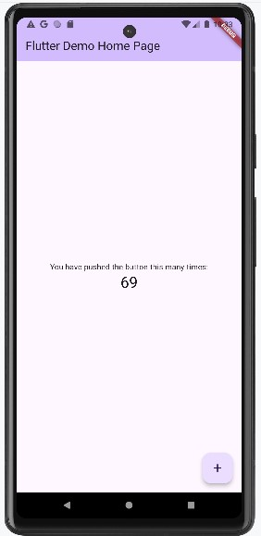

**Assignment 20**

Aim: Create Layout Demo (TextField and ListView) using Flutter.

CODE:

*main.dart* import 'package:flutter/material.dart';

void main() { runApp(const MyApp());

}

class MyApp extends StatelessWidget { const MyApp({super.key});

// This widget is the root of your application.

@override

Widget build(BuildContext context) { return MaterialApp(

title: 'Flutter Demo',

theme: ThemeData( colorScheme: ColorScheme.fromSeed(seedColor: Colors.yellow),

useMaterial3: true,

),

home: const MyHomePage(title: 'Home Page'),

);

} }

class MyHomePage extends StatefulWidget { const MyHomePage({super.key, required this.title});

final String title;

@override

State<MyHomePage> createState() => _MyHomePageState();

}

class _MyHomePageState extends State<MyHomePage> {

@override

Widget build(BuildContext context) { var names=['Apple','Biscuit','Chikku','Dragon Fruit','Elephant','Fruit','Guava']; return Scaffold( appBar: AppBar(

title: Text("List View"),

),

body: ListView.separated(itemBuilder: (context, index)

{ return Text(names[index], style: TextStyle(fontSize: 20, fontWeight: FontWeight.normal),

);

}, itemCount: names.length, separatorBuilder: (context,index)

{ return Divider(height: 50, thickness: 1, color: Colors.blue,); }, )

);

}

}

OUTPUT:

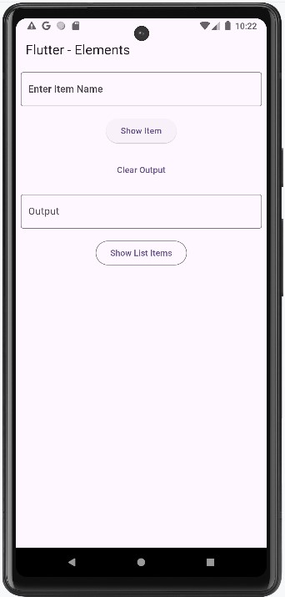

TextField ListView

